DOI: 10.1002/((please add manuscript number))
Article type: Communication

Stereoselective uptake of cell-penetrating peptides is conserved in antisense oligonucleotide polyplexes

Marco Emanuele Favretto and Roland Brock*

Dr. Marco Emanuele Favretto, Prof. Dr. Roland Brock
Dept. of Biochemistry, Radboud Institute for Molecular Life Sciences, Radboud University Medical Centre, Geert Grooteplein 28, 6525 GA Nijmegen
E-mail: r.brock@ncmls.ru.nl

Keywords: oligoplexes, drug delivery, endocytosis, gene therapy, chirality

In nanotechnology, cell-penetrating peptides (CPPs) have gained momentum as a delivery system for cargo that does not cross the plasma membrane. However, their in vivo application remains hampered by their rapid degradation in the bloodstream. The replacement of one or more amino acids with their D-enantiomers confers a higher protease resistance.^{1,2} However, it was shown that D-CPPs have a reduced uptake efficiency for cells with a dense glycocalyx. Such a dense glycocalyx is present on endothelial and epithelial cells, barriers that are highly relevant in drug delivery. Although not completely abolished, their internalization is only 50% of the one of the L-counterparts³. The molecular basis for this difference in activity is still elusive.
One way to employ cationic cell-penetrating peptides as drug delivery vehicles is through non-covalent complexation of nucleic acids, and in particular siRNA and oligonuleotides (ONs).⁴ The role of the CPP in such polyplexes is two-fold: first, protection of the nucleic acids and second induction of cell entry.
To this point, it has not been addressed whether polyplexes made from either D- or L-CPP also differ in their uptake efficiency. One would expect that the cationic nature of such nanoparticulate systems overrules any stereoselectivity observed for individual peptides. For example, in polyethyleneimine (PEI), which is frequently used as a polyplex-forming polymer in oligonucleotide delivery, positive charge is present in a non-chiral context. In addition, proteolysis-resistant D-CPPs should confer higher stability to the complexes. Decomplexation should only occur through displacement of the nucleic acids by polyanions on the cell surface and not by proteolytic degradation.⁵
In order to address the impact of stereochemistry on polyplex delivery, polyplexes were formed from the D- and L- variant of a CPP derived from human lactoferrin (hLF),⁶ and an antisense oligonucleotide that induces splice correction of an aberrant primary luciferase gene transcript. The lactoferrin CPP was chosen as it had shown enantiomer-dependent differences in uptake efficiency³ and the highest delivery efficiency of ON for the group of arginine-rich CPP for which these differences were observed.⁴ We investigated the biological behaviour of polyplexes formed from the D- and L- counterparts and related our findings with their physicochemical properties.
Since the presence of a glycocalyx seems to be an important determinant in the stereoselective internalisation of CPPs, the uptake of D- and L-hLF/ON polycomplexes was tested in HeLa and Jurkat cell lines, which express a high and low density of various glycosaminoglycans, respectively.⁷ In HeLa cells, D-CPPs remain strongly associated to the glycocalyx at the plasma membrane, whereas this association is absent in Jurkat cells.³ Polyplexes were formed from fluorescein-labelled CPP and Cy5-labelled ON in order to enable monitoring of both components by fluorescence techniques.
Interestingly, oligoplexes showed the same behaviour as the free peptides. Uptake by HeLa cells was stereospecific with a higher uptake for polyplexes formed from the L-CPP, whereas the internalization of D- and L-hLF was quantitatively indistinguishable in Jurkat cells. Of particular interest was the distribution of the peptides and ON in HeLa cells. L-hLF/ON oligoplexes showed a high degree of colocalisation between hLF and ON in vesicular structures and some homogenously distributed fluorescein fluorescence was observed. On the other hand, for oligoplexes formed with D-hLF the peptide-associated fluorescence was strongly reduced, yet ON was clearly detectable in vesicular structures (Figure 1). Quantitative image analysis and flow cytometry confirmed that the ON was imported significantly better in the form of complexes than as free ON, and that L-oligoplexes delivered the ON to a higher extent than D-oligoplexes. Nevertheless, for Jurkat cells differences in the intracellular distribution were observed, as well. In both cases, the distribution was very disperse and spared the nucleus. However, for L-hLF the ON-associated fluorescence was more homogeneously distributed, while for D-hLF this was the case for the peptide-associated fluorescence.
To further substantiate these differences, L- and D- polyplexes were added to a co-culture of Jurkat and HeLa cells. Again, in Jurkat cells both types of polyplexes were taken up to the same degree, while for the D-polyplexes, in HeLa cells, only ON-associated fluorescent, but not the peptide, was visible (not shown).
Following the characterisation of uptake efficiencies we were interested to learn, whether the observed differences also resulted in different activities of the ON, as determined with the splice correction assay.⁸ Because of the availability of the cell line, these experiments were restricted to HeLa cells. Despite the significant difference in the internalization and intracellular distribution of the complexes -and the ON itself- there was only a slightly reduced activity of the D-polyplexes in comparison to the L-polyplexes (Figure 2). The observations point to the fact that stereoselectivity-dependent differences in uptake efficiency do not necessarily result in equivalent differences in intracellular activity. Quite evidently, still rather similar amounts of ON reach the cytoplasm over the time frame of the experiment.
For the D-oligoplexes the difference in cell-associated fluorescence for the peptide was much larger than for the oligonucleotide. In order to understand the fate of D-hLF, D-oligoplexes were tracked by time-lapse confocal microscopy. In some instances, once a polyplex that showed fluorescence in both channels contacted the plasma membrane, only the red ON-associated fluorescence entered the cell as a punctuated structure indicative of decomplexation followed by endocytosis of the ON (Figure 3 and supplemental movies). However, the time-lapse analyses did not allow a conclusion whether such a decomplexation was the source of all punctate structures showing only red fluorescence.
For fluorophores in densely packed NPs, quenching of fluorescence may occur. In order to address whether the loss of fluorescein fluorescence in the case of D-peptide was a consequence of such quenching, cells were treated with mild detergent or chloroquine. While mild detergent was meant to release peptide from membranes, chloroquine was employed to neutralise the acidic pH of the endosomes.⁹ Both, the addition of Tween and chloroquine led to the appearance of punctuated structures in the cells. In the case of detergent, these structures localized to the periphery of the cells, while for chloroquine they appeared directly inside the cytosol; in both cases, a partial colocalisation with ON-positive structures was observed (Figure S1). Taken together, these observations support, at least in part, that polyplexes dissociate at the level of the plasma membrane but to some extent enter the cells as intact structures and quenching of fluorescein does indeed occur. Also after dequenching, the intensity for D-hLF was still lower than for L-hLF. The same was the case for the free peptide (Figure S2).
We hypothesized that the different behavior between D- and L-oligoplexes may be due to different physicochemical properties. Dynamic light scattering (DLS) and Laser-Doppler anemometry measurements revealed that the complexes were indistinguishable based on their size, in both water and full culture medium, and zeta-potential. However, upon incubation with heparin both types of polyplexes varied greatly in their stability towards this polyanion. Heparin, which was used as an analogue of HS present on the plasma membrane, caused L-oligoplexes to aggregate into bigger complexes, while for the D-oligoplexes a high percentage fell apart as concluded from the much lower count rate and size (Figure 4A and S3). To ensure that these differences in sensitivity were not a result of differences in peptide concentration, polyplexes were formed at different peptide concentrations. Except for a ratio of 75:1, D-polyplexes were less stable.
At this point we were interested to learn whether these characteristics were restricted to the hLF-derived CPP. Therefore, we extended our analyses to the CPP nonaarginine (R9). Oligoplexes consisting of D- and L-nonaarginine and ON showed the same trend (Figure 4B and S3). Release of ON is a key characterstic of oligoplexes which may have a deep impact on their biological properties. The use of a single-stranded ON, howerver, did not enable a determination of release by gel-shift assays, which can be employed for siRNA, and restricted the array of suitable analytical techniques exclusively to DLS.
Taken together our results show that stereochemistry is a decisive parameter in the formation and activity of polyplexes. Also in the polyvalent arrangement of positive charges that is formed through the peptide-driven formation of nanoparticles, uptake efficiency is governed by the same structure-activity relationship as for the free peptide. On the physicochemical level, D-CPPs form looser complexes than L-CPPs; this translates in oligoplexes that dissociate at the level of a glycocalyx-bearing plasma membrane.
Stereochemistry-related differences are also observed in intracellular trafficking and it is reasonable to assume that these can at least in part be explained by the differences in stability towards heparin-induced decomplexation. It will be highly interesting to further explore whether also for CPP variants with less pronounced differences in uptake structure-activity relationships observed for free peptides are maintained in nanoparticles.¹⁰

Experimental Section

Refer to Supporting Information.

Supporting Information

Supporting Information is attached at the end of the manuscript.

Received: ((will be filled in by the editorial staff))
Revised: ((will be filled in by the editorial staff))
Published online: ((will be filled in by the editorial staff))

[1] Elmquist, A.; Langel, U., Biological chemistry 2003, 384 (3), 387-93. DOI 10.1515/BC.2003.044.
[2] Youngblood, D. S.; Hatlevig, S. A.; Hassinger, J. N.; Iversen, P. L.; Moulton, H. M., Bioconjugate chemistry 2007, 18 (1), 50-60. DOI 10.1021/bc060138s.
[3] Verdurmen, W. P.; Bovee-Geurts, P. H.; Wadhwani, P.; Ulrich, A. S.; Hallbrink, M.; van Kuppevelt, T. H.; Brock, R., Chemistry & biology 2011, 18 (8), 1000-10. DOI 10.1016/j.chembiol.2011.06.006.
[4] van Asbeck, A. H.; Beyerle, A.; McNeill, H.; Bovee-Geurts, P. H.; Lindberg, S.; Verdurmen, W. P.; Hallbrink, M.; Langel, U.; Heidenreich, O.; Brock, R., ACS nano 2013, 7 (5), 3797-807. DOI 10.1021/nn305754c.
[5] Kumar, P.; Wu, H.; McBride, J. L.; Jung, K. E.; Kim, M. H.; Davidson, B. L.; Lee, S. K.; Shankar, P.; Manjunath, N., Nature 2007, 448 (7149), 39-43. DOI 10.1038/nature05901.
[6] Duchardt, F.; Ruttekolk, I. R.; Verdurmen, W. P.; Lortat-Jacob, H.; Burck, J.; Hufnagel, H.; Fischer, R.; van den Heuvel, M.; Lowik, D. W.; Vuister, G. W.; Ulrich, A.; de Waard, M.; Brock, R., The Journal of biological chemistry 2009, 284 (52), 36099-108. DOI 10.1074/jbc.M109.036426.
[7] Verdurmen, W. P. R.; Wallbrecher, R.; Schmidt, S.; Eilander, J.; Bovee-Geurts, P.; Fanghanel, S.; Burck, J.; Wadhwani, P.; Ulrich, A. S.; Brock, R., J Control Release 2013, 170 (1), 83-91.
[8] Kang, S. H.; Cho, M. J.; Kole, R., Biochemistry 1998, 37 (18), 6235-9. DOI 10.1021/bi980300h.
[9] Khalil, I. A.; Kogure, K.; Akita, H.; Harashima, H., Pharmacological reviews 2006, 58 (1), 32-45. DOI 10.1124/pr.58.1.8.
[10] Wallbrecher, R.; Verdurmen, W. P.; Schmidt, S.; Bovee-Geurts, P. H.; Broecker, F.; Reinhardt, A.; van Kuppevelt, T. H.; Seeberger, P. H.; Brock, R., Cellular and molecular life sciences : CMLS 2014, 71 (14), 2717-29. DOI 10.1007/s00018-013-1517-8.

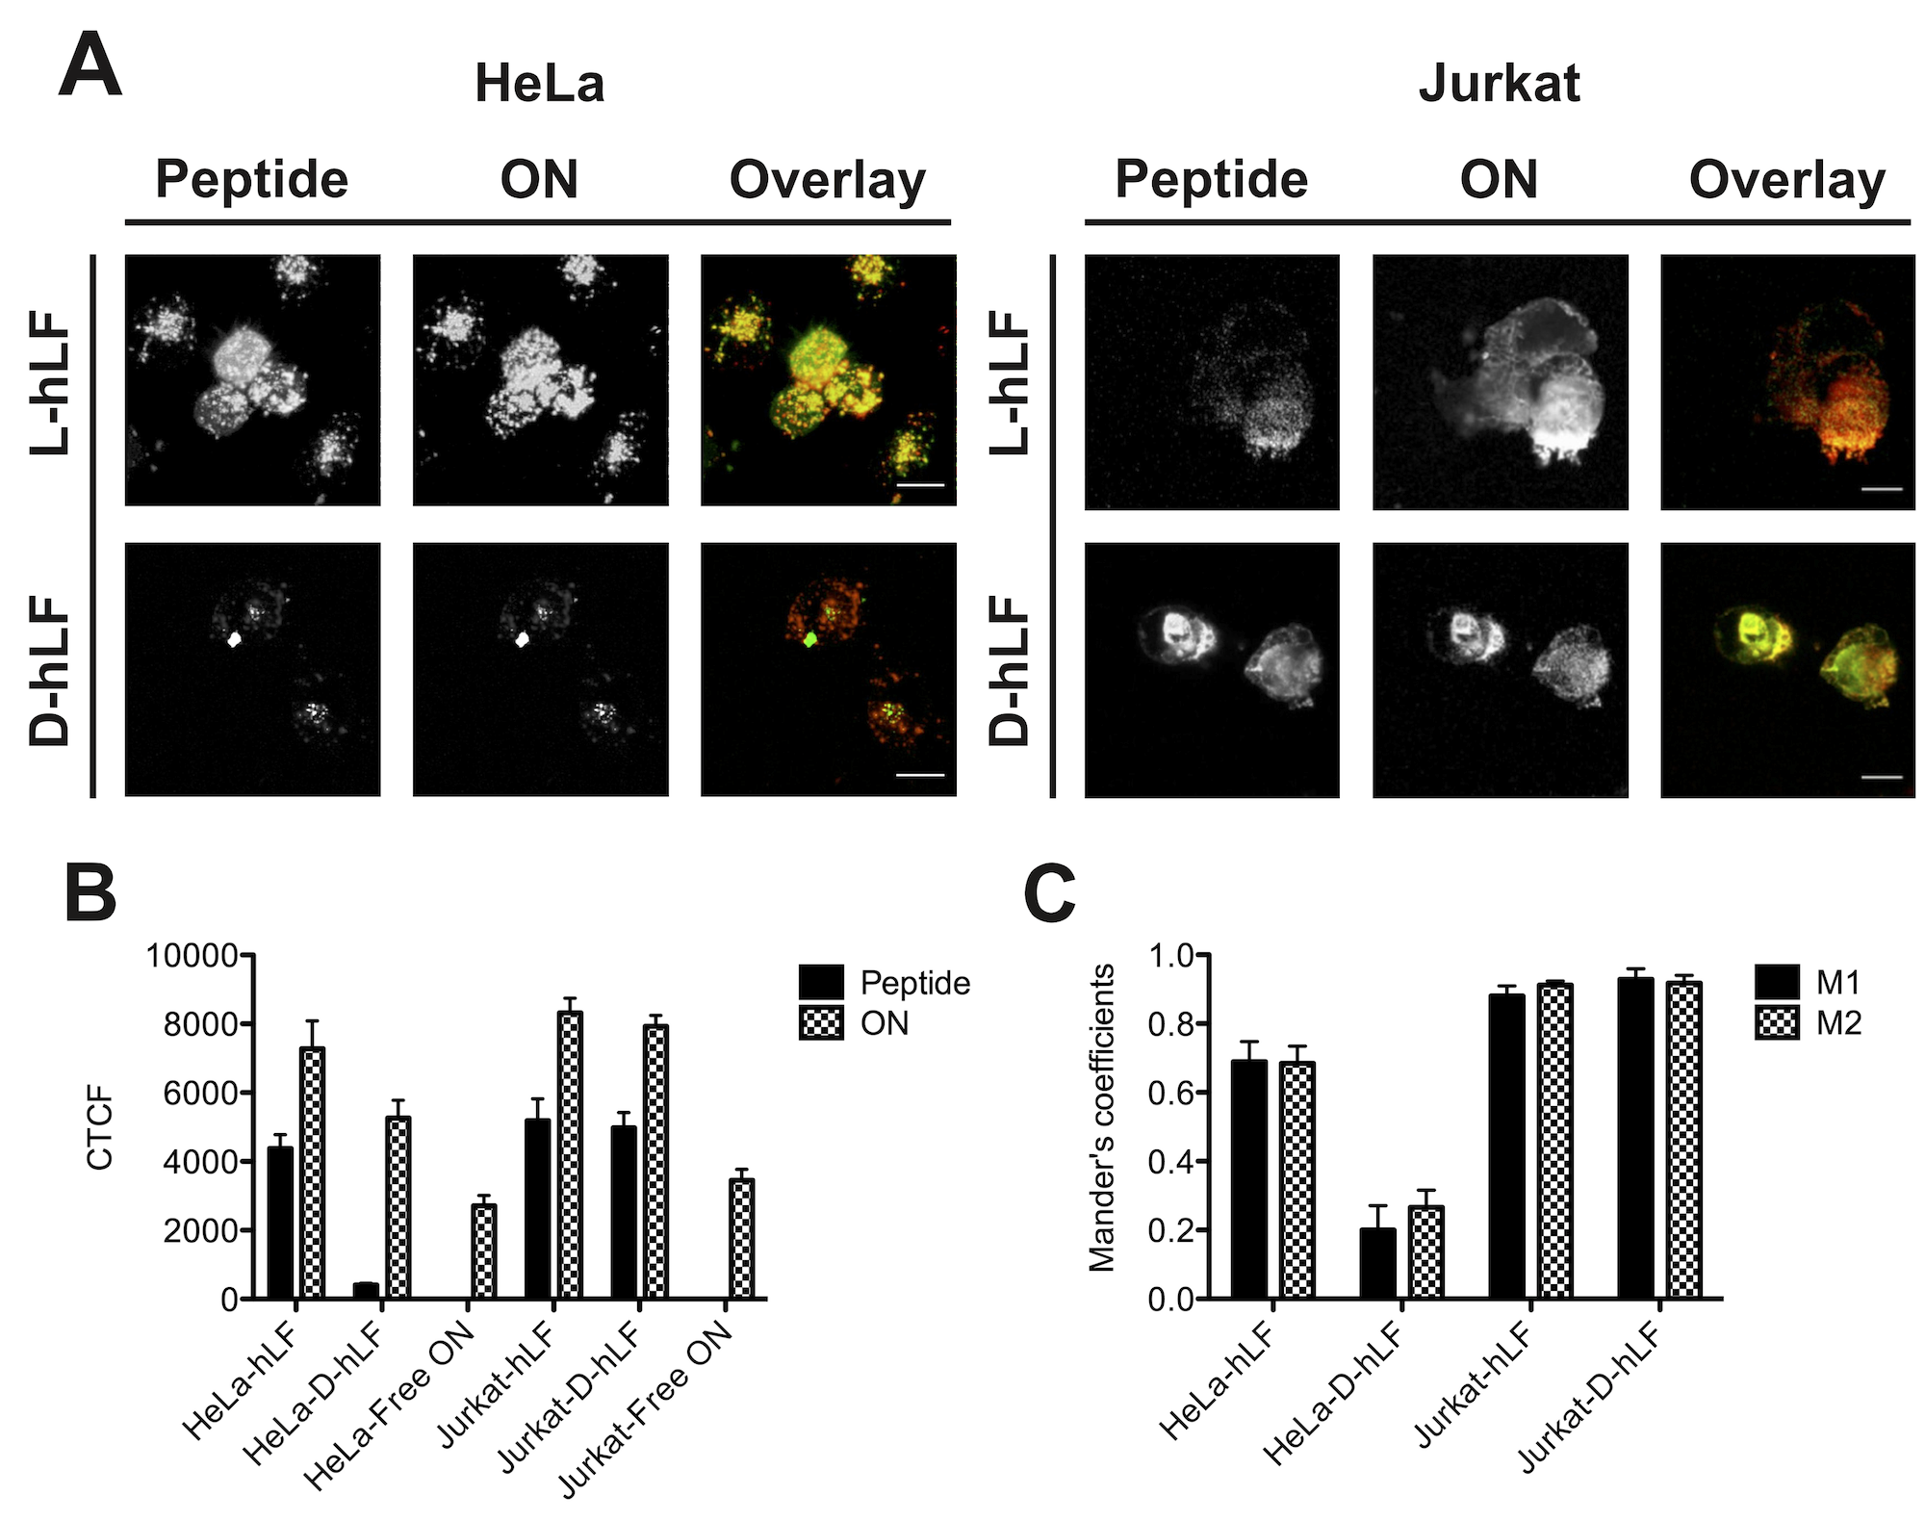
Figure 1: (A) Confocal microscopy images of HeLa (left panel) and Jurkat (right panel) cells, incubated for 1 hour with D- and L-hLF/ON oligoplexes. Peptide: green; ON: red; scale bar = 20 μm. (B) Corrected total cell fluorescence of peptides and ON in HeLa and Jurkat cells determined by image analysis. Results are expressed as mean ± SEM (n=30). (C) Mander’s colocalization coefficients (M1: peptide; M2: ON) determined for oligoplexes in HeLa and Jurkat cells. Results are expressed as mean ± SEM (n=30).
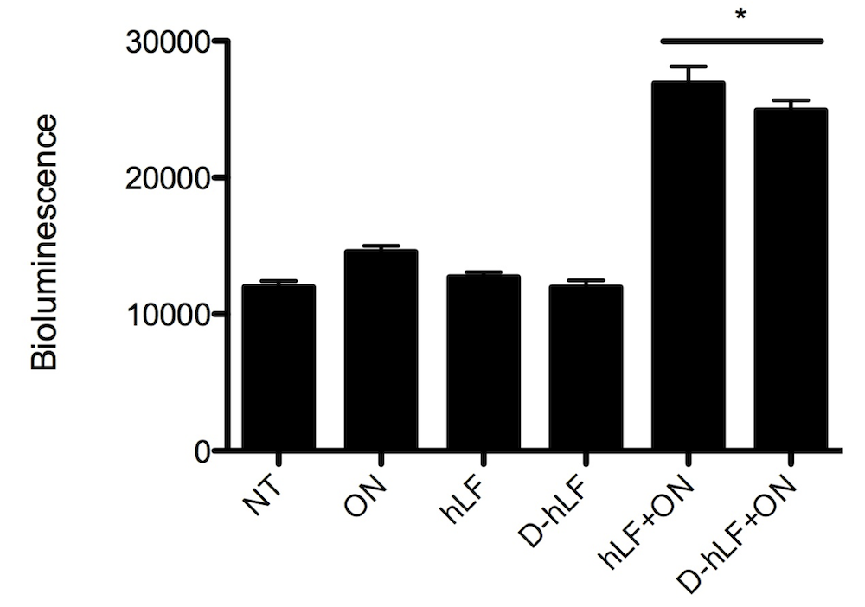
Figure 2: Bioluminescence after oligonucleotide delivery. HeLa cells were incubated with oligoplexes, free oligonucleotide (80 nM) and free peptides, for 1 hour at 2 µM (peptide concentration). Bioluminescence readings were taken 48 hours after incubation. Samples were normalized to the total protein content (10 µg/mL). Results are expressed as mean ± SEM (n=3). * indicates p<0.05.
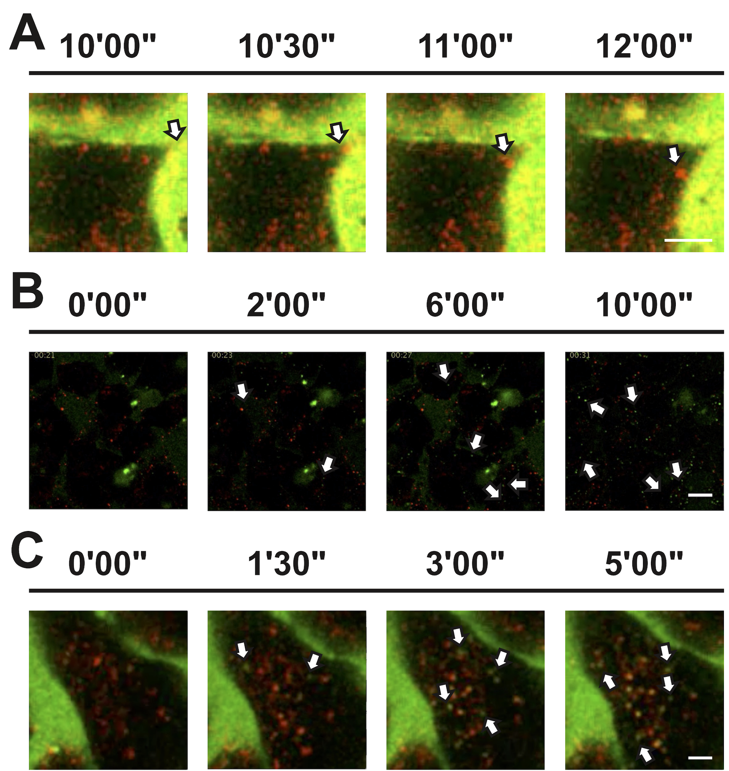
Figure 3: Time-lapse confocal microscopy of D-oligoplexes on HeLa cells. (A) Complexes (arrow) dissociating upon encounter with the plasma membrane. Scale bar = 2 μm. (B) Peptide (arrow) was liberated from the plasma membrane upon treatment with mild detergent and entered the cells by endocytosis. Scale bar = 20 μm. (C) Peptide-fluorescence is increased (arrow) upon treatment with chloroquine. Green: peptide. Red: ON. Scale bar = 2 μm.

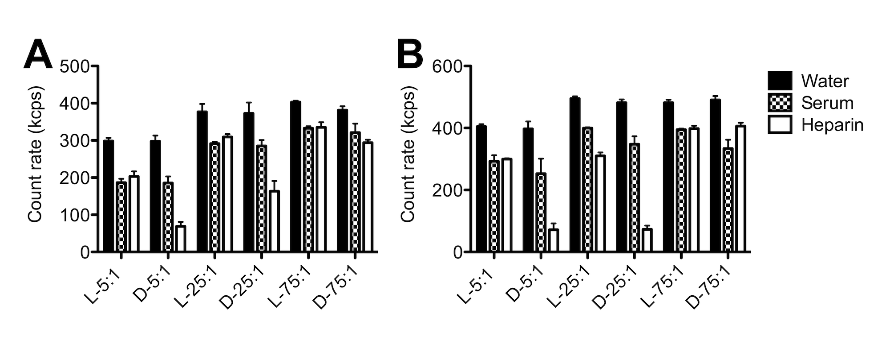
Figure 4: Count rate of D- and L-hLF oligoplexes, at increasing molar ratio of peptide over ON (5:1, 25:1 and 75:1) in water, full culture medium and heparin. D-oligoplexes are more susceptible to heparin-driven decomplaxation than their L- counterpart. (A): hLF; (B): R9. Results are expressed as mean ± SEM (n=3).

Stereochemistry matters. The results present a significant conceptual advancement in the understanding on how functional characteristics of delivery peptides can translate into functional characteristics of peptide-based oligoplexes.

Keyword: oligoplexes, drug delivery, endocytosis, gene therapy, chirality

Marco Emanuele Favretto and Roland Brock*

Stereoselective uptake of cell-penetrating peptides is conserved in antisense oligonucleotide polyplexes

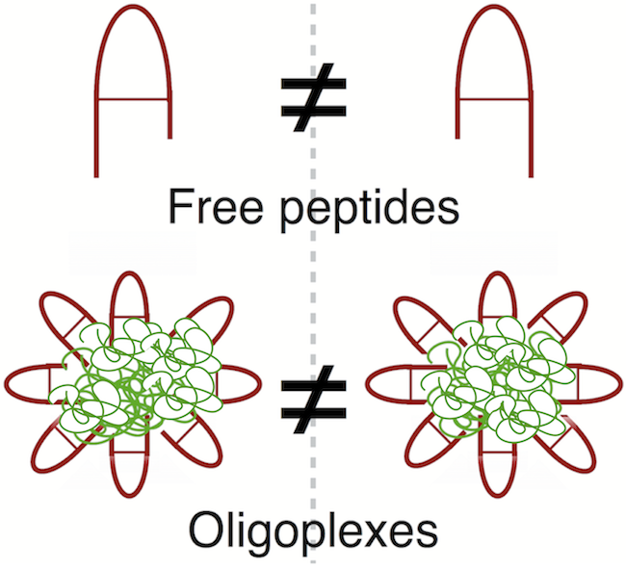
Copyright WILEY-VCH Verlag GmbH & Co. KGaA, 69469 Weinheim, Germany, 2013.

Supporting Information

Stereoselective uptake of cell-penetrating peptides is conserved in antisense oligonucleotide polyplexes

Marco Emanuele Favretto and Roland Brock*

EXPERIMENTAL SECTION
Formation of oligoplexes and their characterization
Polyplexes of D- or L-CPP and oligonucleotides were formed by mixing peptides and Cy5-labelled 2’-OMe-ON-705 (5'-CCUCUUACCUCAGUUACA-3) in water, in a molar ratio of 25:1 Upon mixing and vigorous vortexing for 30 seconds, polyplexes were left for annealing for 30 minutes at room temperature. After annealing, the size of polyplexes upon 1:5 v/v dilution in water or in RPMI 1640 culture medium supplemented with 10% fetal calf serum was measured at 25 °C by dynamic light scattering (DLS) at a backscatter angle of 173°, using a Malvern Nanosizer ZS (Malvern, UK). The zeta-potential of the complexes in water was measured by Laser Doppler Anemometry, using a Malvern Nanosizer ZS (Malvern, UK). To probe for polyanion-induced decomplexation, polyplexes (molar ratio 5:1, 25:1 and 75:1) were incubated for 30 minutes with heparin at heparin/ON molar ratios of 5:1. Immediately after incubation, samples were measured by DLS, using a backscatter angle of 173° at 25 °C
Cell culture
HeLa pLuc 705 cells, which are stably transfected with a reporter construct for determination of delivery of a splice-correcting oligonucleotide, were grown as monolayers in RPMI-1640 medium, supplemented with 10% fetal calf serum and 200 mM L-glutamine, at 37 °C, in a humidified atmosphere containing 5% CO₂. Cells were passaged every 2 days or at 80 to 90% confluency. Jurkat cells were grown in suspension in the same culture medium and split every 2 days.

Determination of cellular uptake of oligoplexes
HeLa pLuc and/or Jurkat cells were plated (4x10⁴ cells/well) in an eight-well microscopy chamber (Ibidi, Panegg, Germany). Cells were incubated at 37°C with oligoplexes (2 µM peptide concentration for HeLa, 1 µM peptide concentration for Jurkat) for 2 hours in full culture medium. Cells were washed twice with medium after the incubation with peptides, and living cells were analyzed immediately or after settling for about 15 min in the microscopy chambers (Jurkat cells) by confocal microscopy (Leica SP5, equipped with an HCX PL APO 63x NA 1.2 water immersion lens, Leica Microsystems, Mannheim, Germany). Colocalization was quantitated using the Colocalization Threshold plugin in FIJI, using a total of 30 cells per condition from 3 independent experiments (10 cells per experiment).
Time-lapse confocal microscopy of oligoplexes was performed using a Leica SP8 confocal microscope, equipped with an HCX L APO 63x NA 0.9 water immersion lens (Leica Microsystems, Mannheim, Germany). Treatments with Tween 20 (1% v/v) or chloroquine (65 µM) were conducted after endocytosis of oligonucleotide (approximately 15 minutes after incubation of cells with oligoplexes). Cells were washed twice with full culture medium before the addition of Tween 20.

Transfection efficiency/splice correction assay
Transfection efficiency was assessed by a splice correction assay using HeLa pLuc 705 cells. Briefly, HeLa pLuc 705 cells (8 x 10⁴ cells/well) were incubated with oligoplexes (2 µM peptide concentration) in RPMI 1640 culture medium supplemented with 10% FCS in a 96-well plate for 2 hours at 37 °C. After incubation, polyplex-containing medium was replaced with fresh medium and cells were incubated for a further 48 hours. 20 µL of lysis reagent were added into each well. Upon normalization to total protein content, lysates were mixed with 100 µL of luciferase assay reagent. Bioluminescence was measured after 3 minutes using a BioTek Synergy 2 plate reader.

Statistical analysis
All the data reported in this article are the result of at least three independent experiments. Statistical significance was calculated by one-way ANOVA or t-test, as appropriate. The confidence interval was set at 95%. Data were analyzed using The R Project for Statistical Computing (http://www.r-project.org, version 2.14).

SUPPLEMENTARY FIGURES
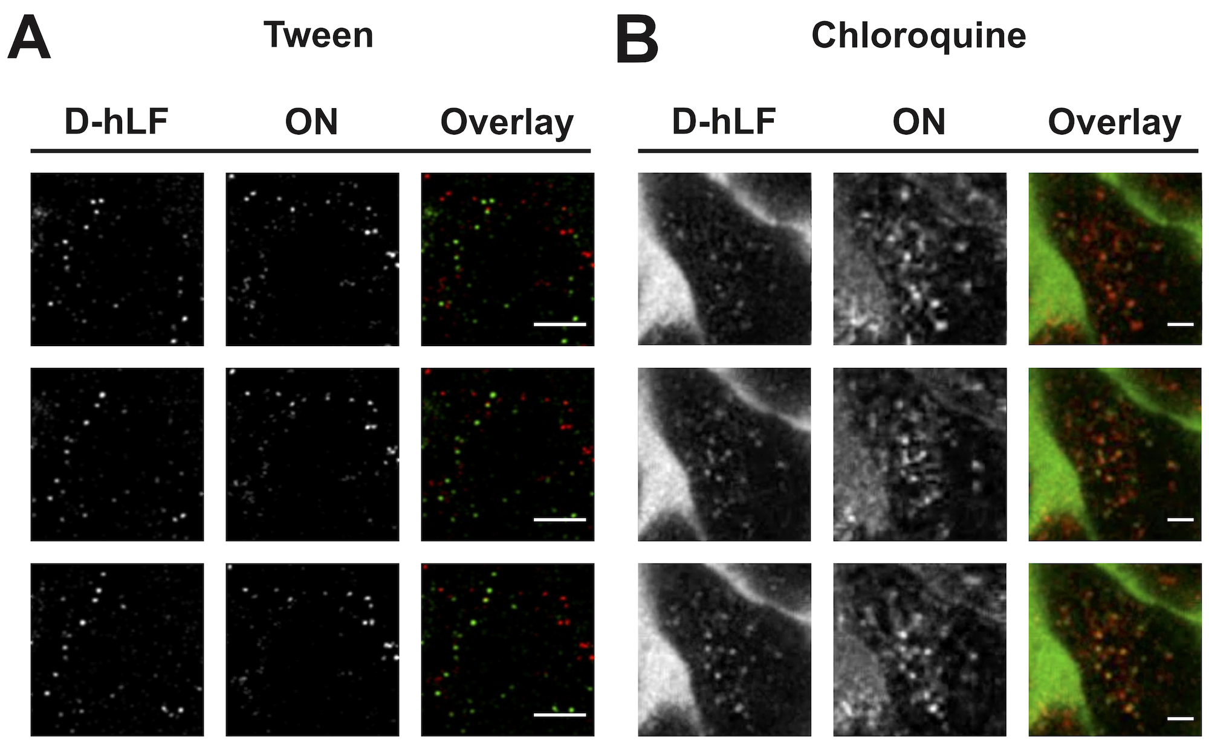
Figure S1: Time-lapse confocal microscopy of D-oligoplexes on HeLa cells, upon treatment with Tween (A) and chloroquine (B). Split-channel and overlay show only a partial colocalization of peptide and ON. Green: peptide. Red: ON. Cells were washed before addition of Tween. Scale bar = 2 μm.

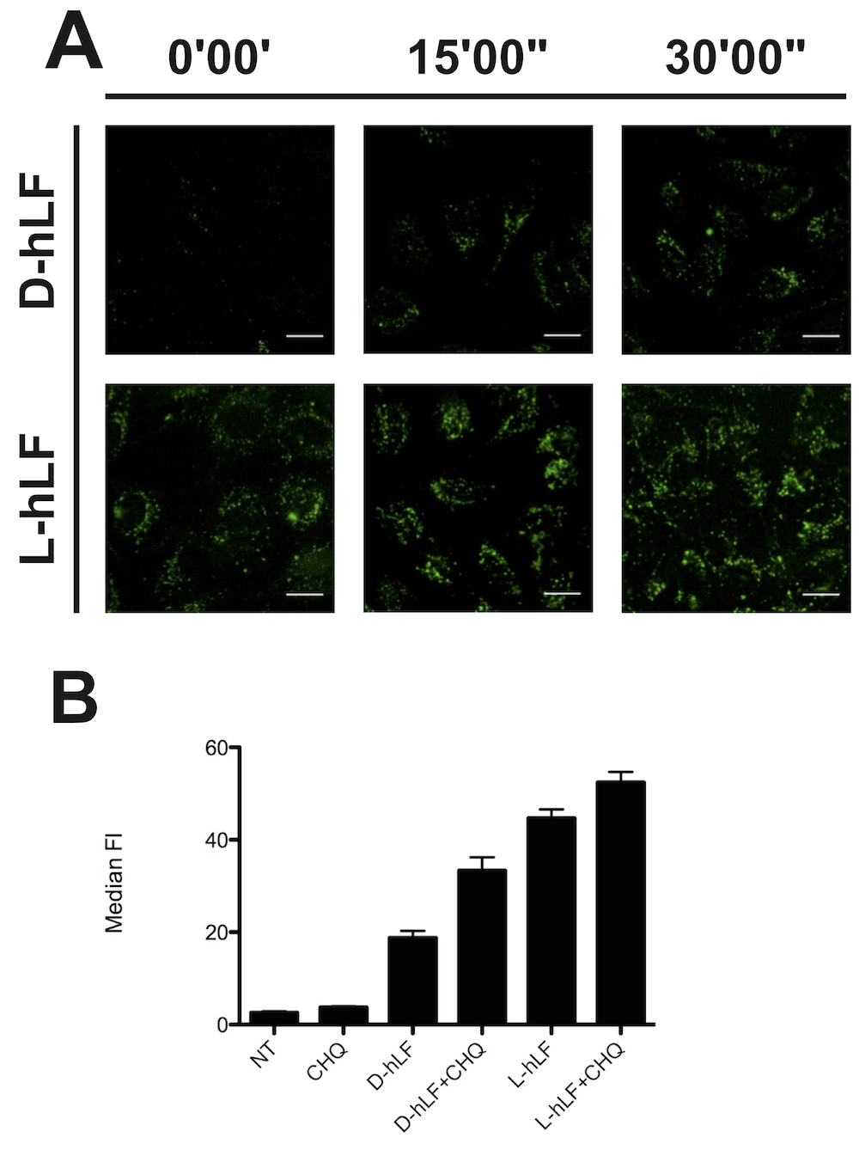
Figure S2: Also for free peptide peptide-associated fluorescence is increased upon treatment with chloroquine. (A) Confocal microscopy image of HeLa cells, immediately after addition of chloroquine (0’00”) and after 15’ and 30’ incubation. Scale bar = 20 μm. (B) Median fluorescence intensity, as calculated by flow cytometry, of HeLa cells treated with fluorescein-labelled D- and L-hLF, before and after treatment with chloroquine (CHQ). Results are expressed as mean ± SEM (n=3).

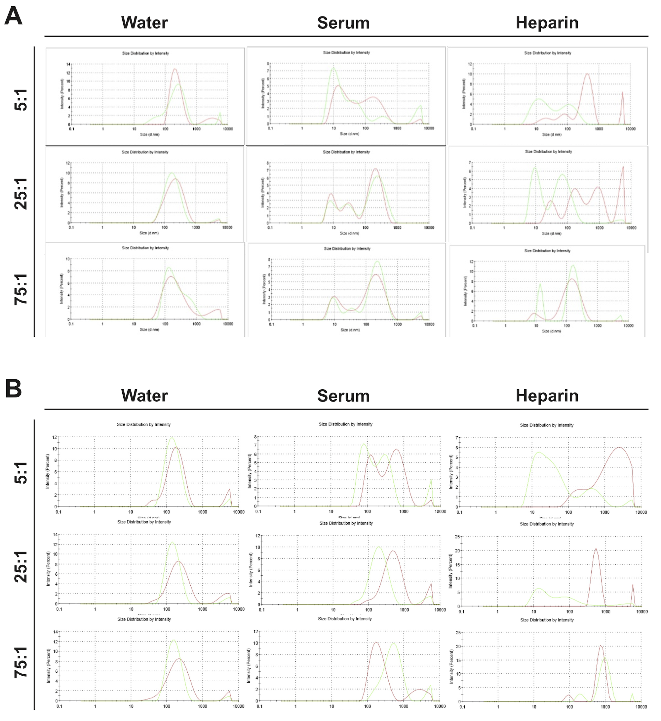

Figure S3: DLS intensity graphs of (A) D- and L-hLF and (B) D-and L-R9 polyplexes, incubated at increasing peptide/ON molar ratios (5:1, 25:1, 75:1) in water, serum-containing culture medium and heparin. Red: L-peptide; green: D-peptide.

