Page 1 of 48 Human Molecular Genetics

1
2 Sarco(endo)plasmic reticulum ATPase (SERCA) is a molecular partner of Wolfram
3
4 syndrome 1 (WFS1) protein, which negatively regulates its expression.
5
6
7
8 Zatyka M (1), da Silva Xavier G (4), Bellomo EA (4), Leadbeater W (2), Astuti D (1), Smith
9
10
11 J (1), Michelangeli F (3), Rutter GA (4), Barrett TG (1)*.
12
13
14
15
16
17 From: Departments of Medical and Molecular Genetics (1), and Neurotrauma and Neurodegeneration
18
19 (2), School of Clinical and Experimental Medicine, The Medical School; and School of Biosciences
20
21 (3), University of Birmingham, Birmingham, B15 2TT, UK. Email: m.m.zatyka@bham.ac.uk,
22
23 d.p.astuti.1@bham.ac.uk, leadbewe@adf.bham.ac.uk, smithjg@adf.bham.ac.uk ,
24
25 f.michelangeli@bham.ac.uk , t.g.barrett@bham.ac.uk. Tel: 01213339267. Fax: 01213339272.
26
27 Department of Cell Biology (4), Division of Medicine, Faculty of Medicine, Imperial Centre for
28
29 Translation and Experimental Medicine, Hammersmith Hospital, Du Cane Road, London W12 0NN,
30
31 UK. Tel: (0)20 759 43340. Fax: (0) 20 759 43351. Email: elisa.bellomo@kcl.ac.uk , g.dasilva-
32
33 xavier@imperial.ac.uk , g.rutter@imperial.ac.uk.
34
35
36
37 *Address correspondence to: Timothy G Barrett, C/O School of Clinical and Experimental Medicine,
38
39 The Medical School, University of Birmingham, Birmingham B15 2TT, UK. Tel: 01213339267. Fax
40
41 01213339272.
42
43
Human Molecular Genetics
Page 2 of 48

1
2 SUMMARY
3
4 Wolfram syndrome is an autosomal recessive disorder characterised by neurodegeneration and
5
6 diabetes mellitus. The gene responsible for the syndrome (WFS1) encodes an endoplasmic
7
8 reticulum (ER)-resident transmembrane protein that is involved in the regulation of the
9
10 unfolded protein response, intracellular ion homeostasis, cyclic AMP production and regulation
11
12 of insulin biosynthesis and secretion. In this study, single cell Ca2+ imaging with fura-2 and
13
14 direct measurements of free cytosolic ATP concentration ([ATP]CYT) with adenovirally
15
16 expressed luciferase confirmed a reduced and delayed rise in cytosolic free Ca2+ concentration
17
18 ([Ca2+]CYT), and additionally, diminished [ATP]CYT rises in response to elevated glucose
19
20 concentrations in WFS1 depleted MIN6 cells. We also observed that SERCA expression was
21
22 elevated in several WFS1 depleted cell models and primary islets. We demonstrated a novel
23
24 interaction between WFS1 and SERCA by co-immunoprecipitation in Cos7 cells and with
25
26 endogenous proteins in human neuroblastoma cells. This interaction was reduced when cells
27
28 were treated with the ER stress inducer dithiothreitol (DTT). Treatment of WFS1 depleted
29
30 neuroblastoma cells with the proteosome inhibitor MG132 resulted in reduced accumulation of
31
32 SERCA levels compared with wild type cells. Together these results reveal a role for WFS1 in
33
34 the negative regulation of SERCA and provide further insights into the function of WFS1 in
35
36 calcium homeostasis.
37
38
39
40
41
42 Word count 204
43
Page 3 of 48 Human Molecular Genetics

1
2 INTRODUCTION
3
4 There is increasing evidence that endoplasmic reticulum (ER) perturbation plays a critical role in cell
5
6 death in both neurodegenerative disorders (1,2) and diabetes mellitus (3,4). Abnormal release of
7
8 calcium from the ER has been observed in several pathological conditions affecting the nervous
9
10 system (5,6). ER stress, oxidative stress, palmitate, and chronic high glucose, all decrease pancreatic
11
12 beta cell ER calcium levels, leading to beta cell death (7).
13
14
15
16 The ER functions as a calcium store through the expression of at least 3 types of proteins: the sarco-
17
18 endoplasmic reticulum calcium ATPase (SERCA) family of proteins that actively pump calcium into
19
20 the ER; luminal calcium binding proteins for storing calcium; and the gated calcium channels inositol
21
22 trisphosphate receptors (IP3R) and ryanodine receptors (RyR) for the controlled release of calcium
23
24 from the ER along its electrochemical gradient (8). ER calcium depletion may be associated with,
25
26 among others, toxin interaction with the IP3R (GM1 gangliosidosis (9)); over-activation of the RyR
27
28 (Gaucher disease (6)); SERCA inhibition (Sandhoff disease (10)) and increased SERCA expression as
29
30 a compensatory mechanism through regulation by ATF6 during the ER stress response (11).
31
32
33
34 Childhood-onset diabetes mellitus and progressive optic atrophy are the diagnostic features of
35
36 Wolfram syndrome, a genetic form of both diabetes and neuro-degeneration (12). In this disease,
37
38 pancreatic beta cells and presumably neuronal cells are selectively destroyed due to mutations in the
39
40 WFS1 gene, which encodes WFS1 protein or Wolframin, an ER transmembrane protein (13). The
41
42 mechanism is thought to be through perturbed ER homeostasis (14, 15) leading to ER stress (16,17).
43
44 Loss of function mutations in WFS1 have been shown to lead to ER calcium depletion (18), increased
Human Molecular Genetics
Page 4 of 48

1
2 depleted MIN6 cells, we observed increased SERCA protein expression. These observations prompted
3
4 us to investigate the possibility of an interaction between WFS1 protein and SERCA.
5
6
7
8
9
10
11
12
13
14
15
16
17
18
19
20
21
22
23
24
25
26
27
28
29
30
31
32
33
34
35
36
37
38
39
40
41
42
43
44
Page 5 of 48 Human Molecular Genetics

1
2 RESULTS
3
4 Wolframin-depleted beta cell lines show reduced insulin secretion in response to elevated glucose
5
6 or KCl-concentrations.
7
8 Wolframin has been implicated in the normal control of stimulus-secretion coupling during regulated
9
10 insulin secretion in vivo and in vitro (16,17). To study the effects of Wolframin depletion on insulin
11
12 secretion and Ca2+ signalling in β-cells, we used the MIN6 insulinoma cell line. These stable cell lines
13
14 have been engineered to provide reduced WFS1 expression using RNA interference, with 0% (wild
15
16 type), 50% (KDA) or 70% (KDB) reduction in Wolframin expression achieved by expression of
17
18 suitable scrambled or anti-WFS1 shRNAs (16, 20).
19
20
21
22 Insulin release in response to glucose (30 vs 3 mmol/l) was decreased in WFS1 depleted cells (Fig.
23
24 1A). At 30mmol/l glucose (30G) the percentage of insulin released was decreased seven-fold for
25
26 KDA (p=2.2 x10-7) and four-fold for KDB (p= 4.5 x 10-7) cells respectively in comparison to wild
27
28 type. At 3mmol/l glucose (3G), and after depolarisation with 50mmol/l KCl (HK), the percentage of
29
30 insulin released was also decreased in KDA and KDB cells, but only reached significance in the KDA
31
32 cells.
33
34
35
36
37 Wolframin-depleted primary islets from WFS1 conditional KO mice show defective insulin
38
39 secretion in response to glucose.
40
41
42 To confirm that Wolframin is necessary for normal insulin secretion in response to high glucose we
43
44 isolated pancreatic islets from beta cell selective conditional WFS1 knock out (KO) mice, a kind gift
Human Molecular Genetics
Page 6 of 48

1
2
3
4 The isolation of islets and insulin secretion assay were performed as described in Materials and
5

6
7 Methods. The percentage of insulin released in response to glucose (17 vs 3mmol/l) during static
8
9 incubation for 1 h was decreased about 65% in islets from Wfs1 KO mice in comparison to size
10
11 matched control islets: percentage of insulin released by control islets (C) = 1.55±0.08%, while by
12
13 KO islets= 0.54±0.15%, p=0.0006, (Fig1B). After depolarization with 20mmol/l KCl (HK) the
14
15 percentage of insulin released from KO islets was also reduced in comparison to the control but did
16
17 not reach statistical significance. These results confirmed the results obtained in MIN6 cells and are
18
19 consistent with previous in vivo and the in vitro findings (16,17, 21).
20
21
22
23
24 Wolframin depletion results in a delayed and reduced glucose-induced rise in cytoplasmic free
25
26 Ca2+.
27
28 The above results suggested that alterations in glucose sensing may result in diminished glucose-
29
30 induced insulin secretion in WFS1-depleted cells. To explore this possibility further, we investigated
31
32 glucose- and KCl-induced cytosolic calcium ([Ca2+]i) rises in single, fura-2-loaded cells. The baseline
33
34 [Ca2+]i for each cell type was calculated as the average of the first 180 seconds of each experiment in
35
36 perifusion buffer containing 3 mmol/l glucose, using the ratio of the emissions after exciting the dye
37
38 at 340 and 380nm. There were no apparent differences in baseline [Ca2+]i between the cell lines
39
40 (340:380 ratios (F/F0): wild type cell 0.30± 0.005; KDA 0.28± 0.003; KDB 0.32± 0.004, and the F/F0
41
42 at the start of experiment was assumed to be equal 1for each cell line).
43
Page 7 of 48 Human Molecular Genetics

1
2 KDA: p=3.2 x10-14; wild type v KDB: p=2.8x10-12 ; KDA v KDB: p=0.3; wild type n=61, KDA n=36,
3
4 KDB n=21 cells).
5
6
7
8 The delay before a detectable increase in [Ca2+]i following stimulation with 30 mmol/l glucose was
9
10 also more than 2-fold longer in WFS1 depleted cells than in wild type cells (Fig. 2E). Whilst the wild
11
12 type cells responded after 203.7± 6.8 s, KDA and KDB cells responded only after 410.0 ± 12.9 and
13
14 416.7± 15.4 s respectively (p values: wild type vs KDA: p=6.2 x 10-18; wild type vs KDB: p=7.3 x
15
16 10-16; KDA v KDB: p=0.3). All cell lines responded similarly to depolarisation with 50 mmol/l KCl
17
18 (Fig. 2A, B, C). The response to 50mmol/l KCl was quantitated by measurement of the area under the
19
20 curve (AUC) and is presented on Fig. 2F (AUC for wild type, KDA and KDB were: 435.1±9.0;
21
22 447.3± 15.8, 445.1± 16.2 respectively, wild type n=61, KDA n=36, KDB n=21 cells).
23
24
25
26 Cytosolic free Ca2+ concentrations at baseline are not significantly different in Wolframin
27
28 depleted cells compared to wild type cells.
29
30 To confirm that there was no apparent differences in baseline [Ca2+]i between the cell lines we
31
32 measured [Ca2+]CYT in wild type and KDB cells with cytosolic (untargeted) aequorin. Our results
33
34 (Fig.3) showed only a slightly higher level of cytosolic Ca2+ in KDB than in wild type cells. The
35
36 results come from two independent experiments (wild type n =8; KDB n =9 separate measurements),
37
38 and are consistent with our earlier findings of no significant differences in baseline [Ca2+]i between the
39
40 cell lines in single, fura-2-loaded cells.
41
42
43
Human Molecular Genetics
Page 8 of 48

1
2 (25). Representative traces showing the apparent increase in free [ATP]CYT (as photon counts) for wild
3
4 type, KDA and KDB respectively are presented in Fig. 4 A,B,C, with quantitative analysis in Fig. 4D.
5
6 The increase in [ATP]CYT in response to high glucose was 14.1% ± 0.6 for the wild type MIN6 cells
7
8 (Fig. 4A), consistent with previous results (22,23,26) but only 4% ± 1.4 for KDA (p=7.43 x 10-5 )
9
10 (Fig. 4B) and 1.3% ± 0.3 for KDB (p= 1.8 x10-13) (Fig 4C). The apparent rise in [ATP]CYT in
11
12 response to high glucose was approximately three-fold less in KDA than in wild type MIN6 cells and
13
14 about ten-fold lower in KDB than in wild type MIN6 cells; (n, wt=12, n, KDA=6 and n, KDB=12 runs
15
16 in three separate experiments for KDB and two separate experiments for KDA) (Fig. 4D).
17
18
19
20 To determine whether changes in the apparent [ATP]CYT increase in response to glucose may be due to
21
22 alterations in Ca2+ pumping into the ER or other intracellular stores, we monitored the impact of
23
24 pharmacological depletion of these stores on the observed changes (Fig. 4). Interestingly, and in
25
26 contrast to previous studies (27), inhibition of SERCA pumps with cyclopiazonic acid (CPA)
27
28 decreased the magnitude of the glucose-induced rise in [ATP]CYT in wild type cells, presumably
29
30 reflecting enhanced ATP consumption for Ca2+ transport by other mechanisms (e.g. extrusion across
31
32 the plasma membrane by PMCA (plasma membrane Ca2+ ATPase) or transporting into the lumen of
33
34 Golgi with SPCA (secretory pathway Ca2+ ATPase) (Fig. 4A). By contrast, in both WFS1 depleted
35
36 cell lines, SERCA inhibition increased free [ATP]CYT (Fig 4B,C).
37
38
39
40 To confirm the above results we investigated ATP:ADP ratio rise to glucose using a different (static)
41
42 method as described in Materials and Methods. Briefly, cells were grown in 6 well plates, starved
43
44 overnight in medium with low glucose and on the day of the experiment incubated in buffers with
Page 9 of 48 Human Molecular Genetics

1
2 our earlier finding that the ATP rise in response to high glucose is impaired in WFS1-depleted MIN6
3
4 cells.
5
6
7
8 Total ATP levels are reduced in WFS1 depleted cells.
9
10 We next measured total ATP content in wild type and WFS1-depleted MIN6 cells as described in
11
12 Materials and Methods. The results were normalised for the cell number and presented as Relative
13
14 Luminescence Units (RLU, proportional to the amount of ATP) per 104 cells, (Table 1). The total
15
16 levels of ATP (RLU) were significantly reduced in both WFS1 depleted cell lines to 79% (of the wild
17
18 type) in KDA and 53% in KDB.
19
20
21
22 SERCA expression is increased in WFS1 depleted cells.
23
24
25 The decreased levels of cytosolic ATP could have been the result of an ATP generation defect or ATP
26
27 overconsumption in WFS1 depleted cells. As no defect in oxidative phosphorylation was identified
28
29 previously in Wolfram patient biopsies (29), there was a possibility that ATP may be over-consumed
30
31 in WFS1 depleted cells. One of the major ATP consumers in pancreatic cells is the SERCA calcium
32
33 pump. We hypothesised that SERCA over-activity could result in ATP depletion in WFS1 depleted
34
35 cells and investigated the levels of SERCA expression.
36
37
38 We examined SERCA expression levels in several WFS1 depleted cell models: MIN6 pancreatic
39
40 cells, primary pancreatic islets isolated from conditional Wfs1 KO mice and in WFS1 depleted SK-N-
41
42 AS neuroblastoma cells (Fig 5). All the WFS1 depleted models displayed Unfolded Protein Response
43
44 (UPR) activity, measured as an increase in the levels of ER stress markers (16, 30).
Human Molecular Genetics
Page 10 of 48

1
2 To examine the SERCA expression levels in isolated islets we prepared total protein extracts from 10-
3
4 13 weeks old Wfs1 conditional KO males as described in Materials and Methods. There was a greater
5
6 than 50% increase of SERCA levels in Wfs1 conditional KO islets in comparison to Wfs1 positive
7
8 controls: (C=100%, KO=157.8±17.8, p=0.005, n=4 Fig 5B). Wolfram syndrome manifests also as a
9
10 neurodegenerative disease. Therefore we used three WFS1-depleted neuroblastoma cell lines (KD1-
11
12 KD3) depleted by 60-80% in comparison to the control (C) as described by Gharanei et al., (30) and
13
14 examined the SERCA expression using either Pan-SERCA antibody Y1F4 (Fig 5C) or isoform
15
16 SERCA2 specific antibody (Fig 5D). The expression levels of SERCA were increased in all WFS1-
17
18 depleted cell lines. Fig 5C shows the increased expression levels detected with Pan SERCA antibody
19
20 (KD1=261.8%± 30.8, p=0.02, n=3; KD2=271.2±42.9%, p=004, n=8; KD3=233.7±40.3%, p=0.009,
21
22 n=8, C=100%). We confirmed that this increase is mainly due to an increase in SERCA2 expression.
23
24 Fig 5D shows increased levels of isoform SERCA2 (KD1=189.8±28.6%, p=0.04, n=4;
25
26 KD2=318.9±71.2%, p=0.02, n=6; KD3=301.7±59.3%, p=0.02, n=6, C=100%).
27
28
29 In summary, all WFS-depleted models showed increased levels of SERCA expression, (the main
30
31 contributor being isoform SERCA2). This is consistent with our hypothesis that in WFS1-depleted
32
33 cells SERCA may be overactive.
34
35
36
37
38 WFS1 interacts with SERCA2.
39
40
41 To explain how the absence of WFS1 protein may affect the levels of SERCA expression we
42
43 hypothesized that the two proteins may be molecular partners. We first examined the potential WFS1-
44
45 SERCA2 interaction in an over-expression system. We co-transfected FLAG-SERCA2 plasmid
Page 11 of 48 Human Molecular Genetics

1
2 show that with anti FLAG antibody we were able to precipitate Myc-WFS1 (lane1). No WFS1 was
3
4 detected in lanes 2-4, where either Myc-WFS1/empty FLAG (lane2), empty Myc /FLAG-SERCA2
5
6 (lane3) or empty Myc /empty FLAG (lane 4) plasmids were present. We probed the membrane with
7
8 polyclonal rabbit anti FLAG antibody (bottom panel) to show the input.
9
10
11 In a reciprocal experiment (Fig 6B, right hand side panel) polyclonal rabbit anti c-myc antibody was
12
13 used for co-immunoprecipitation and monoclonal mouse anti FLAG antibody for detection (top
14
15 panel). Only in lane1, where both Myc-WFS1 and FLAG-SERCA2 proteins were expressed, we
16
17 observed co-immunoprecipitation of FLAG-SERCA2. There was no SERCA2 detected in lanes 2-4,
18
19 where either Myc-WFS1/empty FLAG (lane2), empty Myc/ FLAG-SERCA2 (lane3) or empty Myc
20
21 /empty FLAG (lane4) were present. The bottom panel probed with monoclonal mouse c-myc
22
23 antibody shows the input. These results indicate that WFS1 and SERCA2 can interact in an over-
24
25 expression system.
26
27
28 Next we examined if endogenous WFS1 and SERCA2 can be co-immunoprecipitated from SK-N-AS
29
30 neuroblastoma cells (Fig 6C). WFS1 antibody (rabbit polyclonal) were used for precipitation (lane5)
31
32 and a ~110 kDa band was detected with SERCA2 antibody. No SERCA2 was detected in either lane
33
34 4 or 6 where negative controls: either FLAG- rabbit polyclonal or FLAG -mouse monoclonal antibody
35
36 were used for co-immunoprecipitation. Our results indicate that the two proteins, WFS1 and SERCA2
37
38 may interact with each other in SK-N-AS neuroblastoma cells.
39
40
41 To understand the role of this interaction we examined if WFS1 and SERCA2 can interact with each
42
43 other under conditions of ER stress. We prepared protein extracts from neuroblastoma SK-N-AS cells
44
45 either untreated or treated with ER stress inducer: 1mmol/l DTT for 3 hours. First, we examined the
Human Molecular Genetics
Page 12 of 48

1
2 untreated extract was used. Interestingly, the SERCA2 band in the DTT treated sample was much
3
4 reduced (Fig 6D, lane3, top panel). The membrane was re-probed with sheep WFS1antibody and the
5
6 amount of precipitated WFS1 quantified showing equal amounts in both DTT treated and untreated
7
8 samples (DTT:1.0, Untreated:1.0, Fig.6D, lower panel). Next, the amount of precipitated SERCA2
9
10 was quantified, and normalized for the WFS1 levels: (untreated sample: SERCA2 =1.0; DTT treated
11
12 sample: SERCA=0.38). In summary, DTT treatment did not affect either the protein expression or the
13
14 amounts of precipitated WFS1 (Fig 6D). This suggests that the 62% reduced levels of the amount of
15
16 precipitated SERCA2 in DTT-treated sample do not result from reduced levels of precipitated WFS1
17
18 under these conditions. Our results thus suggest that WFS1-SERCA2 interaction may be impaired
19
20 under ER stress conditions.
21
22
23
24
25
26 Proteasome inhibition results in an increase of SERCA2 levels in a WFS1-dependent manner.
27
28
29 We demonstrated above that WFS1 interacts with SERCA and SERCA expression is increased in
30
31 WFS1 depleted cells. We hypothesized that WFS1 may be a negative regulator of SERCA and targets
32
33 SERCA to proteasome mediated degradation. To test our hypothesis we compared SERCA levels in
34
35 control and the WFS1 depleted cell line KD2 after treatment with the proteasome inhibitor MG132.
36
37 Control and WFS1 depleted KD2 cells were treated with either 5 or 10µmol/l MG132 proteasome
38
39 inhibitor as described by Gharanei et al., (30). Equal amounts of protein (11µg) was loaded per lane
40
41 and samples were resolved on SDS PAGE gels. SERCA expression in DMSO treated sample was
42
43 assumed to be equal 100%. Quantification revealed that while in control cells SERCA expression at
44
45 5µmol/l increased to 226.9± 26.5% and at 10µmol/l increase to 266.3±51.9% (2.2 and 2.6 fold
Page 13 of 48 Human Molecular Genetics

1
2 degradation. However, the ubiquitnation assay, in which we compared SERCA ubiquitnation levels
3
4 between KD2 and control cells did not show impaired SERCA ubiquitination in KD2.
5
6
7
8
9 DISCUSSION
10
11 In Wolfram syndrome, diabetes mellitus results from multiple defects in the glucose signalling
12
13 pathway; and both the diabetes mellitus and neurodegeneration are thought to be associated with ER
14
15 calcium depletion. The present study provides additional insights into its role in both mouse pancreatic
16
17 beta cell and human neuroblastoma cell models of the disease. We observed the following: (1) our
18
19 models confirmed that WFS1 protein depletion in MIN6 beta cells and primary islets resulted in
20
21 reduced glucose stimulated insulin secretion, and reduced and delayed cytosolic Ca2+ rise to glucose;
22
23 (2) we observed a reduced cytosolic ATP rise in response to high glucose, and reduced total cellular
24
25 ATP content; (3) SERCA expression levels were increased in WFS1 protein depleted MIN6 cells,
26
27 WFS1 KO primary islets, and WFS1 protein depleted human neuroblastoma cells; (4) WFS1 protein
28
29 interacted with SERCA in both overexpressed and endogenous models; (5) Proteasomal inhibition
30
31 studies suggested a role for WFS1 in SERCA protein turnover. (6) When ER stress was induced with
32
33 DTT, there was a reduced WFS1/SERCA complex formation or partial dissociation, allowing SERCA
34
35 expression to increase. These results are consistent with a model in which WFS1 protein negatively
36
37 regulates the ER stress response and modulates ER calcium filling by regulating SERCA expression to
38
39 partially compensate for ER calcium depletion in conditions of ER stress.
40
41
42
43 We showed that in two MIN6 β-cell models of Wolframin depletion there was reduced glucose
44
45 stimulated insulin secretion (Fig 1A). We also demonstrated the defect in glucose stimulated insulin
46
47 secretion in primary islets isolated from conditional beta cell specific knock out mice (Fig.1B). In our
48
49 MIN6 model of Wolframin depletion, this was associated with a delayed and reduced amplitude of
50

the [Ca2+]i rise (Fig 2), and reduced [ATP]CYT rise in response to elevated glucose (Fig 4). These
51
Human Molecular Genetics
Page 14 of 48

1
2 Our findings of reduced [ATP]CYT rise in response to elevated glucose, and reduced total cellular ATP,
3
4 suggest reduced ATP synthesis or increased ATP consumption after WFS1 silencing (22,27). This
5
6 reduced [ATP]CYT rise may explain the observed reduced and delayed glucose-induced [Ca2+]i rise in
7
8 these mutants (due to failed closure of ATP-sensitive K+ channels). ATP generation defects have not
9
10 been previously reported in Wolfram syndrome; our own previous work demonstrated normal
11
12 oxidative phosphorylation in muscle biopsies from Wolfram patients (29). Increased ATP
13
14 consumption could arise from cellular efforts to restore ER homeostasis. SERCA pump activity has
15
16 been shown to be a major ATP-consuming process in MIN6 cells (27) and has also been proposed as a
17
18 negative regulator of [ATP]CYT, contributing to the Ca2+-dependent oscillations in [ATP]CYT observed
19
20 in beta cells (33,34).
21
22
23
24 These observations led us to hypothesise that ATP utilisation by SERCA may increase in the absence
25
26 of WFS1 protein; and further, that increased activity/expression of SERCA would be observed in
27
28 WFS1 protein depletion. To test our hypothesis we studied the levels of SERCA expression in several
29
30 models of WFS1 depleted cells: pancreatic MIN6, SK-N-AS neuroblastoma and in primary islets
31
32 isolated from WFS1 conditional knock out mice. All our models showed elevated ER stress markers
33
34 (16,30). We found that SERCA levels were significantly elevated in all our models and that it was
35
36 mainly due to increased levels of isoform SERCA2 (Fig 5). This is a novel finding and to the best of
37
38 our knowledge, there are no published reports of SERCA expression in WFS1 protein depleted cell
39
40 models.
41
42
43
44 We demonstrated that WFS1 and SERCA interact in both an over-expression system (Fig 6AB) and
45
46 endogenously (Fig 6C); and that this interaction is reduced in the presence of DTT-induced ER stress
47
48
49 (Fig 6D). Inhibition of the proteasome with MG132 resulted in accumulation of SERCA in a WFS1
50
51 dependent manner: the accumulation of SERCA expression was reduced in WFS1 depleted
Page 15 of 48 Human Molecular Genetics

1
2 depleted cells (data not shown). We tested for “canonical “ signals for proteasomal recognition with
3
4 antibody against ubiquitin lysine-48 based chains. However, several “non canonical” ubiquitin based
5
6 signals for proteasomal targeting have also been described (e.g. polyubiquitin chains assembled
7
8 through residues other than lysine 48), tagging substrates with “ubiquitin like” proteins, or
9
10 proteasomal degradation without prior ubiquitination (35). Therefore the mechanism of WFS1
11
12 regulation of SERCA requires further confirmation.
13
14
15
16 It seems that the regulation of SERCA protein levels by WFS1 may be ER stress dependent: under
17
18 conditions of ER stress SERCA is released from the interaction with WFS1 (or alternatively SERCA-
19
20 WFS1 complexes are formed at a lower rate), it may be degraded by the proteasome to a lesser extent,
21
22 and SERCA expression increases. Under normal conditions of ER homeostasis the physiological
23
24 levels of SERCA may be maintained in homeostasis by interaction with WFS1. A similar function for
25
26 WFS1 was described by Fonseca et al., (15) who demonstrated that WFS1 negatively regulates a key
27
28 transcription factor involved in ER stress signalling Activating Transcription Factor 6α (ATF6α)
29
30 through the ubiquitin-proteasome pathway.
31
32
33
34 Some forms of ER stress result in ER calcium depletion, disturbed ER functions and increase in
35
36 cytosolic calcium levels which may trigger cell death via activation of the calpain-2 apoptotic pathway
37
38 (7). We provide evidence that under conditions of WFS1 protein depletion, there may be a secondary
39
40 increase in SERCA expression to pump calcium ions back into the ER calcium store to try to restore
41
42 ER homeostasis. Several reports show that induction of ER stress may lead to increased SERCA
43
44 expression on both mRNA and protein levels (36,37,38,11,39). In addition Wu et al., (40) reported that
45
46 cytosolic calcium elevation itself increased SERCA2 expression by a mechanism distinct from ER
47
48
49 stress. The authors speculated that enhanced calcium uptake into the ER might shorten the period of a
50
51 relative ER calcium depletion subsequent to a stimulus–induced ER calcium release, in this way
Human Molecular Genetics
Page 16 of 48

1
2 function may increase to restore ER calcium levels; in irresolvable ER stress, ER calcium levels
3
4 cannot be restored SERCA expression falls and apoptosis ensues.
5
6
7
8 The absence of WFS1 is associated with ER stress (14,15,16,17), calcium leak from the ER and an
9
10 elevation of cytosolic calcium levels (7). ER stress, ER calcium leak and elevations of cytosolic
11
12 calcium have all been associated with increases in SERCA expression (11,36,37,38,40). ATF6 is also
13
14 negatively regulated by WFS1, and a downstream effect of increased ATF6 activity is elevation of
15
16 SERCA expression (11). It may be that under these conditions for the cells to survive SERCA
17
18 expression must be increased to counteract the ER calcium leak to restore ER calcium homeostasis
19
20 and to prevent activation of cell death pathway induced by elevated cytosolic calcium levels. The
21
22 decrease of SERCA levels under ER stress and under some pathological conditions observed by Hara
23
24 et al., (7) was in the presence of WFS1, where induction of this compensatory mechanism was not
25
26 necessary; WFS1 exerted its pro-survival function and prevented cell death. Our results, summarised
27
28 on Fig 8, are consistent with the possibility that WFS1 negatively regulates SERCA turnover, possibly
29
30 via proteasome mediated degradation and this process is dependent on the ER stress. Release of
31
32 SERCA from interaction with WFS1 in WFS1 depleted cells or under ER stress may result in
33
34 increased SERCA levels and activity and may allow compensatory pumping of calcium ions from
35
36 cytosol to ER lumen to restore ER calcium homeostasis and prevent cell death.
37
38
39
40 To further understand WFS1 role in calcium homeostasis it will be interesting to examine if/how
41
42 WFS1 depletion affects the expression of inositol trisphosphate (IP3) receptors and ryanodine
43
44 receptors (RYR), the calcium channels that release calcium from the ER; and how WFS1 depletion
45
46 affects other intracellular Ca2+ stores.
47
48
49
50
51 In summary, our results support previously reported WFS1 involvement in regulation of glucose
Page 17 of 48 Human Molecular Genetics

1
2 Materials and Methods.
3
4 Cell culture and adenoviral infection
5
6 Mouse β-cell-derived MIN6 cells expressing interfering RNAs to provide reduction in WFS1
7
8 expression (16) were cultured in Dulbecco’s modified Eagle’s medium (Sigma) containing 25mmol/l
9
10 glucose, 2mmol/l pyruvate, supplemented with 15% (vol/vol) FBS, 4mmol/l glutamine, 100 units/ml
11
12 penicillin, 100 µg/ml streptomycin, 143 µmol/l β-mecaptoethanol and 0.2 mg/ml geneticin. Luciferase
13
14 expression was achieved by infection of cells with adenoviral vector encoding cytoplasmic-targeted
15
16 luciferase (AdCMVcLuc) (22), aequorin expression by using untargeted cytosolic aequorin (Cyt.Aq)
17
18 (43). Human neuroblastoma SK-N-AS cells with stable WFS1 depletion were grown as described by
19
20 Gharanei et al., (30).
21
22
23
24 Insulin secretion from MIN6 cells.
25
26 Cells were seeded in six-well plates and grown in full growth medium for at least 16 hours, before
27
28 they were maintained overnight in medium with 3mmol/l glucose. Insulin secretion was performed as
29
30 previously described (http://www.jbc.org/content/280/27/25565.long) and insulin content measured by
31
32 radioimmunoassay (Millipore).
33
34
35
36 Isolation of pancreatic islets, insulin secretion assay and preparation of protein extracts.
37
38
39 The mice used in this experiment were beta cells selective conditional Wfs1 knock-out mice (16),
40
41 obtained by collaboration from Professor A. Permutt. They were additionally back crossed with C57
42
43 wild type females for two generations and the heterozygotes were used as parents in matings to obtain
44
45 experimental and control littermates. Islets were isolated by collagenase digestion from pancreata of
46
47 10-13 weeks old male mice: either Wfs1 conditional knock out mice (Wfs1 fl/fl Cre cre/+ ) or Wfs1
48
49 positive “floxed” littermates (Wfs1 fl/fl ). Islets of Langerhans were isolated, cultured and insulin
50
51 secretion assay performed as previously described (26,44).
Human Molecular Genetics
Page 18 of 48

1
2 µl of buffer). For homogenization the lysate was multiple times frozen (at -80C) and defrosted at RT,
3
4 each time being passed several times through pipette tip followed by passing through a 21.5G size
5
6 needle (26,44).
7
8
9
10
11 Cytosolic free Ca2+ concentration measurements with fura-2
12
13
14 Cells were seeded on 24 mm diameter coverslips and starved in medium containing 3mmol/l glucose
15
16 overnight. The next day, cells were loaded with the fluorescent dye fura-2 (5µmol/l), and incubated in
17
18 Krebs buffer (see above) with 3mmol/l glucose. Next, the cells were perifused with buffer containing
19
20 3mM glucose followed by 30mmol/l glucose, then 50mmol/l KCl as a control. Changes in ([Ca2+]i) in
21
22 single cells were measured as the changes in fluorescence intensity of fura-2 using an Olympus IX-80
23
24

inverted optics epifluorescence microscope (x40 oil immersion objective). Single cell [Ca2+]
i
25
26 measurements were performed exciting the dye at 340 and 380nm and emission was recorded at
27

28
29 510nm. Images were recorded with an IMAGO charge-coupled device camera (Till Photonics GmbH,
30
31 Grafelfing, Germany) controlled by Tillvision software (Till Photonics).
32
33
34
35 Measurements of cytosolic free Ca2+ with recombinant targeted aequorin.
36
37 Cells were seeded onto 13 mm diameter coverslips and 24 h later, at 70-80% confluency, transfected
38
39 with adenoviruses expressing the untargeted (cytosolic) bioluminescent protein aequorin (45,46).
40
41 Forty eight hours later, cells were depleted of Ca2+ by incubation with 10µmol/l ionomycin, 10µmol/l
42
43 cyclopiazonic acid (CPA) and 10µmol/l monensin in modified Krebs-Ringer bicarbonate buffer
44
45 containing glucose 3mmol/l, Hepes 10mmol/l, KCl 3.5mmol/l, MgSO4 0.5mmol/l, NaCl 140mmol/l,
46
47 NaHCO3 2mmol/l, and NaH2PO4 0.5mmol/l (to achieve pH 7.4), and supplemented with EGTA
48
49 1mmol/l for 5 min at 4C (46). Cytosolic free calcium levels were measured using a cytoplasmic (non
50
51 targeted) aequorin construct and native coelenterazine (47). Aequorin was reconstituted with 5µmol/l
Page 19 of 48 Human Molecular Genetics

1
2 to the perifusion chamber and converted to Ca2+ concentration [µmol/l] using algorithms described
3
4 previously (50,51).
5
6
7
8 Cytosol free ATP concentration measurements
9
10 Cells were seeded onto 13 mm diameter coverslips and 24h later, at 70-80% confluency infected with
11
12 adenovirus expressing untargeted (cytosolic) firefly luciferase (22,23). After 48h culture, the cells
13
14 were “starved” overnight in medium containing 3mmol/l glucose. The following day, the cells were
15
16 incubated for a further 15 min. in modified Krebs buffer containing 3mmol/l glucose, then perifused in
17
18 the same buffer containing 3mmol/l glucose, followed by buffer with 30mmol/l glucose and then
19
20 followed by addition of CPA (10µmol/l), an inhibitor of SERCA. The cytosolic free ATP
21
22 concentration ([ATP]CYT) was estimated by counting the emitted photons with a photomultiplier as
23
24 described above.
25
26
27
28 Measurements of ATP: ADP ratio in response to rise in glucose concentration.
29
30 Cells were seeded in 6 well plates in standard media. The next day the cells were starved overnight in
31
32 the medium with 3mmol/l glucose. On the day of experiment the cells were incubated for 15 min in
33
34 Krebs buffer with 3mmol/l glucose; and after that they were incubated for 15 min in Krebs buffer
35
36 with either 3mmol/l glucose (plate1), 30mmol/l glucose (plate2) or 30mmol/l glucose and CPA
37
38 (plate3). The plates 1 and 2 were harvested after 15 min in 200µl per well of 20% (v/v) ice cold
39
40
41 perchloric acid (PCA) and rapidly frozen in -80°C. 10µmol/l CPA was added to plate 3 and incubated
42
43 additional 5 min before being harvested in PCA as above. In parallel, another plate was seeded in
44
45 identical way for measurements of protein concentration to normalise the results and harvested in
46
47 protein lysis buffer (RIPA). Standard curve for ATP and ADP (a negative control) was prepared
48
49 (gradient of concentrations versus luminescence). The samples (harvested in PCA) were neutralised to
50
51 pH7.4 with a known volume of neutralisation mixture (0.5mol/l triethanolamine, 2mol/l KOH and
Human Molecular Genetics
Page 20 of 48

1
2 where ADP was converted to ATP by addition of pyruvate kinase. After two hours incubation at RT,
3
4 10µg of luciferase and 1mmol/l luciferin were added to each sample and luminescence was measured
5
6 on luminometer for both: set1 (ATP) and set2 (ATP+ADP). The amount of ADP was calculated as a
7
8 difference ADP = (ATP+ADP)-ATP (28).
9
10
11
12
13
14 Total cellular ATP content
15
16 Cells were grown to 90% confluency in standard medium (see above) with 25mmol/l glucose,
17
18 harvested, diluted 10x in growing medium, counted and seeded in opaque-walled 96 wells plates
19
20 (Appleton Woods). The following day total ATP assay was performed using the CellTiter-Glo
21
22 Luminescent Cell Viability Assay (Promega). Briefly, the plates were equilibrated to room
23
24 temperature for 30 min, and a volume of reconstituted CellTiter-Glo Reagent (100µl to 100µl of
25
26 medium in each well) was added. The content was mixed for 2 min. in an orbital shaker to induce
27
28 lysis; after 10 min incubation in room temperature the luminescence was read on a multilabel counter
29
30 Wallac 1420 Victor3 (Perkin Elmer).
31
32
33
34 Preparation of microsomal fractions.
35
36
37 8 x T75cm flasks of each: wt, KDA and KDB MIN6 (80% confluent) were harvested by
38
39 trypsinisation, rinsed with PBS and resuspended in 2mls of PBS on ice. Cells were spun down at 2000
40
41 rpm, 5 min, 4ºC and suspended in 10mls of MEMBRANE buffer (5mM HEPES, 0.32M sucrose pH7.2
42
43 with protease inhibitors) before they were homogenised using electric homogeniser Polytron, ultra
44
45 Turro T8 at 30 000rpm for 10 sec. Then, cells were transferred to glass electric homogeniser and
46
47 homogenised with 10 strokes. Cells were spun down at 10000g, 10min, 4ºC to remove organelles
48
49 (nuclei and mitochondria). Cloudy supernatant (15mls) was harvested to a separate tube, divided
50
51 between two ultracentrifuge tubes (3/4 full) and spun down at 100 000x g for 1 hour at 4˚C.
Page 21 of 48 Human Molecular Genetics

1
2 Proteasome inhibition assay.
3
4 Cells were plated at 5 × 105 cells/well in a 6-well plate. After 24h, cells were treated with either 5 or
5
6 10µmol/l MG132 proteasome inhibitor for 4h, harvested in RIPA buffer and prepared for Western
7
8 Blotting as described by Gharanei et al., (30).
9
10
11
12
13 Immunoblotting.
14
15 Antibody were diluted in 5% milk in PBS-Tween and used at the following concentrations:
16
17 PanSERCA Y1F4 (mouse monoclonal (32)) 1:5000; SERCA2 (goat polyclonal Santa Cruz) 1:1000;
18
19 Beta actin (mouse monoclonal Sigma) 1:14000; PDI (mouse monoclonal Abcam) 1:5000. For protein
20
21 detection in extracts from isolated islets the following concentrations of primary antibody were used:
22
23 WFS1 (rabbit polyclonal, obtained by collaboration (20)) 1:500; PanSERCA Y1F4 1:500, beta actin
24
25 1:3500. Secondary antibody (anti rabbit, goat and mouse, Dako) were used at 1:20000.
26
27
28
29
30
31 Co-immunoprecipitation.
32

33
34 Construction of FLAG-SERCA2 plasmid: full length human SERCA2 (transcript variant b, GeneBank
35
36 NM_170665.3) was amplified from a human cDNA library by PCR using primers 5’-
37
38 CTTGCGGCCGCGATGGAGAACGCGCAC-3’ (forward) and 5’-
39
40 GCATGGTACCTCAAGACCAGAAGATATCG-3’ (reverse) and was cloned between the Not I and
41
42 Kpn I site of pFLAG-CMV4 expression vector (Sigma). The sequence was confirmed by DNA
43
44 sequencing. pCMV-Myc-WFS1 plasmid was described before (20).
45
46
47
48 Transfection: Cos7 cells were seeded at 2.0 x 106 in 10cm plates and after 24h co-transfected with the
49
50 following combinations of plasmids (2µg of each): pCMV-Myc-WFS1/FLAG-SERCA2, pCMV-Myc-
51
52 WFS1/empty FLAG, empty Myc /FLAG-SERCA2 and empty Myc/empty FLAG using Turbofect
Human Molecular Genetics
Page 22 of 48

1
2 Immunoprecipitation in over-expression system: 750µg of protein extract and either anti-FLAG mouse
3
4 monoclonal antibody (Sigma) or anti c-myc rabbit, polyclonal antibody (Sigma) were used for co-
5
6 immunoprecipitation in the over-expression system. The extracts were incubated with antibody
7
8 overnight at 4°C with end to end rotation. Protein G Sepharose beads were added after overnight
9
10 incubation for a further 4 hours of end to end rotation at 4°C. Beads were separated from lysate using
11
12 Spin-X columns (Costar) by centrifugation at 4000 x g for 15 min at 4°C and washed 4 times with
13
14 RIPA buffer (for washes:1, 2 and 4 RIPA buffer with 150mmol/l NaCl was used, for wash 3 RIPA
15
16 buffer with NaCl increased to 500mmol/l was used). Each wash was performed by 15min incubation
17
18 at 4˚C with end to end rotation, followed by spin at 4000 x g. Bound proteins were eluted in 50µl
19
20 sample buffer by heating to 70°C for 8 min followed by 3min spin at a maximum speed in microfuge
21
22 and stored in -80°C. The following antibody were used for immunoblotting: c-myc (rabbit polyclonal,
23
24 Sigma) 1:10000; WFS1 (rabbit polyclonal, Proteintech) 1: 500; FLAG (rabbit polyclonal Sigma)
25
26 1:1000; FLAG (mouse monoclonal, Sigma) 1:1000; c-myc (mouse monoclonal Sigma) 1:1000.
27
28 Secondary anti mouse and anti rabbit antibody (Dako) were used 1:20000.
29
30
31
32 DTT treatment. 80% confluent SK-N-AS cells growing in 10cm dishes were treated with 1mmol/l
33
34 DTT (Sigma) for 3 hours or remained untreated before being harvested in 600µl TBD (composition
35
36 below). Equal amounts of untreated and DTT treated protein lysates were used for co-
37
38 immunoprecipitation as described below.
39
40
41
42 Immunoprecipitation of endogenous proteins: To detect endogenous interaction neuroblstoma SK-N-
43
44 AS cells in 10cm dishes were harvested in 600µl Tris buffer (TBD) per dish (20mmol/l Tris pH7.5,
45
46 with 100mmol/l NaCl, 1%TritonX-100, 1mmol/l DTT, 1mmol/l PMSF and protease inhibitors
47
48
49 (Complete Mini, Roche )), scraped on ice, placed in eppendorfs and incubated at 4˚C with end to end
50
51 rotation for 1 hour. The samples were sonicated 3x10s on ice and the lysates cleared by
52
53 centrifugation at 23000 x g at 4˚C. 900µg-1mg of protein extract (400µl) was used per reaction.
Page 23 of 48 Human Molecular Genetics

1
2 columns (Costar) with 20µl of pre-cleared Protein G Sepharose beads, for 3h incubation at 4˚C with
3
4 end to end rotation. The samples were centrifuged at 4000 x g at 4˚C and the beads washed 2x in
5
6 400µl of buffer TBD-150 (with 150mmol/l NaCl), 1x in TBD-500 (with 500mmol/l NaCl), and again
7
8 1x in TBD-150. Each time the beads were incubated 15-20 min at 4°C with end to end rotation.
9
10 Finally beads were separated from lysates by centrifugation at 4000xg and 50µl of SDS loading
11
12 buffer was added per sample. The proteins were released from beads by heating to 70˚C for 8 min,
13
14 spun down at 13000rpm in microfuge for 3 min and supernatant harvested. The samples were run on
15
16 SDS-PAGE gels, transferred to membranes at (90V for 90 min) and boiled for 4 minutes in water
17
18 before being blocked in 5% milk in PBS-Tween for 1 hour. The membranes were incubated with
19
20 SERCA2 goat polyclonal antibody (Santa Cruz) 1:1000 followed by anti goat secondary antibody
21
22 (Dako) 1:20000, or WFS1 sheep polyclonal antibody (R&D systems) 1: 10000 followed by secondary
23
24 anti sheep (R&D systems) 1:30000 overnight at 4˚C with rotation.
25
26
27
28 Statistical analysis
29
30
31 Data are given as the means ± S.E. for the number of experiments given. Comparisons between means
32
33 were performed using Student’s t-test with Bonferonni correction for multiple testing, as appropriate.
34
35
36
37
38
39
40
41
42
43
44
45
46
47
48
49
50
51
52
53
54 Acknowledgements.
Human Molecular Genetics
Page 24 of 48

1
2 Imperial College Divisional Studentship to EAB. Dr Zatyka is supported by The Birmingham
3
4 Children’s Hospital Research Foundation; Thames Honda; and Wellchild. Dr Zatyka is the recipient of
5
6 a Wellcome Trust VIP award. Patient engagement was through the EURO-WABB project (www.euro-
7
8 wabb.org) funded by The European Commission Health Programme Framework (2010 12 05),
9
10 delivered through The NIHR Wellcome Clinical Research Facility, Birmingham. Dr Boris Kysela
11
12 kindly gave advice on co-immunoprecipitation conditions.
13
14
15
16 Conflicts of interest
17
18 The corresponding author confirms on behalf of all authors that there are no conflicts of interest to
19
20 declare.
21
22
23
24
25
26
27
28
29
30
31
32
33
34
35
36
37
38
39
40
41
42
43
Page 25 of 48 Human Molecular Genetics

1
2 TABLE AND LEGEND
3
4 Table 1. Total ATP content (RLU) of wild type MIN6 and WFS1 depleted MIN6 cells.
5
6 Total ATP content was assayed using CellTiter-Glo Luminescent Cell Viability Assay (Promega) as
7
8 described under Material and Methods. The results are presented as relative luciferase units (RLU) per
9
10 104 cells and as a per cent of ATP content in wild type. The results come from 3 independent
11
12 experiments with n wt =72, n KDB=66, n KDA=72 (t-test: wt vs KDB p=4.8 x 10 -21 ; wt vs KDA
13
14 p=1.0 x 10 -8 ).
15
16
17
18
19
20 Table 1
21
22
23
24
25
26
Cell line | RLU/104 cells ± SE | % (total ATP of wt)
pSuper (WT) | 378691.2± 9283 | 100%
KDA | 297797.4± 10111 | 78.6%
KDB | 198801.5± 12976 | 52.5%

27
28
29
30
31
32
33
34
35
36
37
38
39
40
41
42
43
Human Molecular Genetics
Page 26 of 48

1
2 FIGURE LEGENDS
3
4
5 Fig. 1. Glucose and depolarisation-induced insulin secretion from MIN6 cells and isolated
6
7 pancreatic islets.
8
9 A. Insulin secretion from wild type and WFS1-depleted MIN6 cells. Quantitative analysis of insulin
10
11 secreted in response to 30 mmol/l glucose and 50 mmol/l KCl. Total and released insulin were
12
13 measured by radioimmunoassay as given under Materials and Methods. Wolframin depletion resulted
14
15 in a reduction of the percentage of insulin released in response to 30 mmol/l glucose (***: wt vs KDA
16
17 p=2.2 x10-7, and wt vs KDB p= 4.5 x10-7). The results were from three experiments performed in
18
19 triplicate. 3G: 3 mmol/l glucose, 30G: 30 mmol/l glucose, HK (high potassium): 50 mmol/l KCl.
20
21 B. Glucose induced insulin secretion from primary islets isolated from conditional, beta cell selective
22
23 Wfs1 KO mice. Immunoblot – 70% reduced WFS1 expression in islets isolated from Wfs1 KO mice
24
25 in comparison to the control islets; 10µg of protein extract was loaded per lane. BA: beta actin. Bar
26
27 chart: Quantitative analysis of insulin secreted in response to 17 mmol/l glucose and 20 mmol/l KCl
28
29 measured by radioimmunoassay. The percentage of insulin released in response to 17 mmol/l glucose
30
31 is significantly reduced in islets from KO mice in comparison to size matched control islets (C): (***:
32
33 C vs KO p=0.0006). The percentage of insulin released in response to high potassium (20 mmol/l) is
34
35 also reduced in islets from KO mice, but it did not reach statistical significance (C vs KO p=0.22). No
36
37 difference was measured in response to 3mmol/l glucose (C vs KO p=0.21). The results come from at
38
39 least three experiments in duplicates (for control islets (C) N=3, for KO islets N=6). 3G: 3 mmol/l
40
41 glucose, 17G: 17 mmol/l glucose, HK (high potassium): 20 mmol/l KCl.
42
43
Page 27 of 48 Human Molecular Genetics

1
2 glucose, 30G: 30 mmol/l glucose, HK (high potassium): 50mmol/l KCl. D. Quantitative analysis of the
3
4 increase in free cytosolic Ca2+ concentration (fura-2) to 30 mmol/l glucose measured as AUC (area
5
6 under curve). The response in WFS1 depleted cells was more than 2-fold smaller than wt (***: wild
7
8 type vs KDA: p=3.2 x 10-14, wild type vs KDB: p=2.8 x 10-12 , and KDA vs KDB: p=0.3). E. Delayed
9
10 response of cytosolic calcium rise to 30 mmol/l glucose in Wolframin-depleted cells. The delay before
11
12 a detectable response was more than 2.0 fold longer in WFS1 depleted cells than in wild type cells.
13
14 (***: wild type vs KDA: p=6.2x10-18; wild type vs KDB: p=7.3 x 10-16 and KDA v KDB: p=0.3; n,
15
16 wild type=61; n, KDA=36; n, KDB=21 cells). F. Quantitative analysis of the increase in free
17
18 cytosolic calcium concentration (fura-2) to 50mmol/l KCl measured as AUC; there was no differences
19
20 between WFS1 depleted cells and WT MIN6.
21
22
23
24 Fig. 3. Changes in cytosolic free calcium concentration in wild type MIN6 and Wolframin
25
26 depleted KDB cells. Cells were infected with adenovirus expressing untargeted (cytosolic) aequorin.
27
28 48 h later, cells were depleted of calcium (see Materials and Methods), then perifused in nominally
29
30 Ca2+-free buffer, followed by buffer with 1.5mmol/l CaCl2 as indicated. The figure shows the results
31
32 obtained over two days of experimentation (n wt= 8, n KDB = 9 runs).
33
34
35
36 Fig. 4. Glucose-induced cytosolic free ATP changes in wild type MIN6 and Wolframin-depleted
37
38 cells. Cells were infected with adenovirus expressing cytosolic luciferase and, 48 h later, perifused in
39
40 the presence of 5 µmol/l luciferin in a photon-counting device as described under Materials and
41
42
43 Methods. Representative traces for A: wild type MIN6 cells; B KDA; C: KDB. The y axes represent
Human Molecular Genetics
Page 28 of 48

1
2
3
4 Fig. 5. SERCA expression in WFS1 depleted cell models. Representative immunoblots and bar
5
6 charts showing quantitative analysis. A: SERCA expression in WFS1 depleted MIN6 cells -
7
8 microsomal fractions. Immunoblot: lane 1control (C), lane 2 KDB, 3 KDA. Top panel- PanSERCA
9
10 antibody Y1F4 (32) used for detection, bottom panel- PDI antibody used for normalisation. 22µg of
11
12 microsomal fraction extract was loaded per lane. ( *: C vs KDA p=0.045, C vs KDB p=0.052, n= 6
13
14 runs with two independently prepared microsomal fraction extracts). B: SERCA expression in
15
16 primary islets isolated from Wfs1 conditional KO mice- whole protein extracts. (**: C vs KO
17
18 p=0.005, n=4, using two independently prepared extracts). Top panel -PanSERCA antibody Y1F4
19
20 (32), bottom panel: beta actin (BA). 10µg of protein extract was loaded per lane. C: SERCA
21
22 expression in WFS1 depleted neuroblastoma SK-N-AS cells, total protein extracts. Top panel- Pan
23
24 SERCA antibody Y1F4 (32), bottom panel beta actin (BA). ( *: C vs KD1: p=0.02, n=3; **: C vs
25
26 KD2: p=0.004, n=8; **: C vs KD3: p=0.009, n=8).Two independently prepared KD1 extracts and ,
27
28 five independently prepared KD2 and KD3 extracts were run. 17 µg of protein extract was loaded per
29
30 lane. Lanes: 1 - control, 2 - KD1, 3 - KD2, 4 - KD3. D: Expression of SERCA2 isoform in WFS1
31
32 depleted neuroblastoma SK-N-AS cells- total protein extracts. Top panel: isoform SERCA2 specific
33
34 antibody (Santa Cruz), bottom panel Beta actin (BA). (*: C vs KD1: p=0.04, n=4; C vs KD2: p=0.02,
35
36 n=6; C vs KD3: p=0.02, n=6). Two independently prepared KD1 extracts and 3 independently
37
38 prepared KD2 and KD3 extracts were run. 17 µg of protein extract was loaded per lane. Lanes: 1-
39
40 control, 2 -KD1, 3- KD2, 4 -KD3.
41
42
43
44 Fig.6. Co- immunoprecipitation of WFS1 and SERCA2. A and B: co-immunoprecipitation of
Page 29 of 48 Human Molecular Genetics

1
2 Myc/FLAG-SERCA2; 4: empty-Myc /empty-FLAG; lane 5 (on Co-IP gel): Input- extract expressing
3
4 myc-WFS1 and FLAG-SERCA2. Myc-W1= Myc-WFS1, FL-SERC=FLAG-SERCA2, E-Myc=
5
6 empty vector Myc, E-FL=empty vector FLAG. B: Right hand side panels: IP:Myc -
7
8 immunoprecipitation with c- myc antibody (rabbit polyclonal,). Top panel: immunoblot with FLAG
9
10 antibody (mouse monoclonal,), bottom panel immunoblot with c-myc (mouse monoclonal). Panels
11
12 at the left hand side show the input: the expression of indicated proteins in extracts before co-
13
14 immunoprecipitation (1% of extracts used in Co-IP). Lanes (on both : IP gel and input): 1 Myc-
15
16 WFS1/ FLAG-SERCA2; 2: Myc-WFS1/empty- FLAG; 3: empty-Myc /FLAG-SERCA2; 4: empty-
17
18 MYC /empty- FLAG. C: Co-IP of endogenous WFS1 and SERCA2 from SK-N-AS cells with anti
19
20 WFS1 antibodies (rabbit polyclonal). Immunoblot: SERCA2 (goat polyclonal). Lanes 1-3: Input (1%
21
22 of extracts used for Co-IPs in lanes 4- 6), lane 4: negative control: IP with anti FLAG antibody (rabbit
23
24 polyclonal), lane 5: IP with WFS1 antibody (rabbit polyclonal), lane 6: negative control: IP with
25
26 FLAG antibody ( mouse monoclonal), n=4. D: Co-IP of endogenous WFS1 and SERCA2 from SK-
27
28 N-AS cells after DTT treatment (n=3). Left panel: Input-expression of SERCA2 and WFS1 in DTT
29
30 treated (D) and untreated (U) extracts before immunoprecipitation; note that there is no decrease in
31
32 expression levels for neither of the proteins. Right panel: IP. Lanes: 1-input (2.5% of extract used for
33
34 IP), -lanes 2 and 5 negative controls (IPs with FLAG antibody with untreated and treated extracts
35
36 respectively); lane 3: IP with WFS1 antibody from DTT treated sample; lane 4: IP with WFS1
37
38 antibody from untreated sample. Top panel : immunoblotting with SERCA2 antibody, bottom panel:
39
40 the same membrane probed with WFS1 antibody. Numbers below the gel panels show relative
41
42 quantification of SERCA2 bands intensity normalized with WFS1.
43
Human Molecular Genetics
Page 30 of 48

1
2 panels):1 DMSO: treatment, 2: MG132 at 5µmol/l, 3: MG132 at 10µmol/l. Bar chart- quantification of
3
4 SERCA expression: (*: C v KD2 at 5µmol/l MG132: p= 0.01; C v KD2 at 10µm/l MG132: p= 0.03;
5
6 control n=6 runs, KD2 n=4 runs using two independently treated extracts). MG132_5: treatment with
7
8 5µmol/l MG132; MG132_10: MG132 at 10µmol/l.
9
10
11
12
13 Fig 8. Regulation of ER calcium homeostasis by WFS1 via regulation of SERCA2 levels:
14
15
16 Under conditions of calcium homeostasis (normal conditions) WFS1 interacts with SERCA and
17
18 negatively regulates SERCA turnover to maintain physiological SERCA2 levels. Under conditions of
19
20 ER stress or in WFS1 depleted cells WFS1-SERCA2 interaction is limited: the complex is either not
21
22 formed or formed at a reduced level. This results in SERCA2 upregulation. SERCA2 upregulation
23
24 provides a compensatory mechanism which allows for increased Ca2+ pumping to the ER in response
25
26 to Ca2+ leak from the ER caused by either ER stress or WFS1 depletion. This compensatory
27

28
29 mechanism allows restoration of calcium homeostasis and prevention of cell death.
30
31
32
33
34
35
36
37
38
39
40
41
42
43
Page 31 of 48 Human Molecular Genetics

1
2 REFERENCES
3
4 1. Ilieva, E., Ayala, V., Jové, M., Dalfó, E., Cacabelos, D., Povedano, M., Bellmunt, M., Ferrer, I.,
5
6 Pamplona, R., Portero-Otín, M. (2007) Oxidative and endoplasmic reticulum stress interplay in
7
8 sporadic amyotrophic lateral sclerosis. Brain, 130, 3111-3123.
9
10
11
12
13 2. Hoozemans, J., van Haastert, E., Nijholt, D., Rozemuller, A., Scheper, W. (2007) Activation of the
14
15 unfolded protein response is an early event in Alzheimer's and Parkinson's disease. Neurodegener.
16
For
17 Dis., 10, 212-215.
18
19
20
21
22 3. Cardozo, A., Ortis, F., Storling, J., Feng, Y., Rasschaert, J., Tonnesen, M., Van Eylen, F., Mandrup-
Peer
23
24 Poulsen, T., Herchuelz, A., Eizirik, D. (2005) Cytokines downregulate the sarcoendoplasmic reticulum
25
26 pump Ca2+ ATPase 2b and deplete endoplasmic reticulum Ca2+, leading to induction of endoplasmic
27
28 reticulum stress in pancreatic beta-cells. Diabetes., 54, 452-461.
29
30
31
32
33 4. Gwiazda, K., Yang, T., Lin, Y., Johnson, J. (2009) Effects of palmitate on ER and cytosolic Ca2+
34
35 homeostasis in beta-cells. Am. J. Physiol. Endocrinol. Metab., 296, E690-701.
36
37
38
39 5. Tessitore, A., del P Martin, M., Sano, R., Ma, Y., Mann, L., Ingrassia, A., Laywell, E., Steindler,
40
41 D., Hendershot, L., d'Azzo, A. (2004) GM1-ganglioside-mediated activation of the unfolded protein
42
43 response causes neuronal death in a neurodegenerative gangliosidosis. Mol. Cell., 15, 753-766.
Human Molecular Genetics
Page 32 of 48

1
2 8. Pozzan, T., Rizzuto, R., Volpe, P., Meldolesi, J. (1994) Molecular and cellular physiology of
3
4 intracellular calcium stores. Physiol. Rev., 74, 595-636.
5
6
7
8
9 9. Sano, R., Annunziata, I., Patterson, A., Moshiach, S., Gomero, E., Opferman, J., Forte, M., d'Azzo,
10
11 A. (2009) GM1-ganglioside accumulation at the mitochondria-associated ER membranes links ER
12
13 stress to Ca(2+)-dependent mitochondrial apoptosis. Mol. Cell., 36, 500-511.
14
15
16
17
18 10. Pelled, D., Lloyd-Evans, E., Riebeling, C., Jeyakumar, M., Platt, F., Futerman, A. (2003)
19
20 Inhibition of calcium uptake via the sarco/endoplasmic reticulum Ca2+-ATPase in a mouse model of
21
22 Sandhoff disease and prevention by treatment with N-butyldeoxynojirimycin. J. Biol. Chem., 278,
23
24 29496-29501.
25
26
27
28 11. Thuerauf, J., Hoover, H., Meller, J., Hernandez, J., Su, L., Andrews, C., Dillmann, W.,
29
30 McDonough, P., and Glembotski C. (2001) Sarco/endoplasmic reticulum calcium ATPase-2
31
32 expression is regulated by ATF6 during the endoplasmic reticulum stress response: intracellular
33
34 signalling of calcium stress in cardiac myocytes model system. J. Biol. Chem., 276, 48309-48317.
35
36
37
38 12. Barrett, T., Bundey, S., and Macleod, A. (1995) Neurodegeneration and diabetes-UK nationwide
39
40 study of Wolfram (DIDMOAD) syndrome. Lancet, 346, 1458-1463.
41
42
43
44 13. Inoue, H., Tanizawa, Y., Wasson, J., Behn, P., Kalidas, K., Bernal-Mizrachi, E., Mueckler, M.,
Page 33 of 48 Human Molecular Genetics

1
2 14. Fonseca, S., Fukuma, M., Lipson, K., Nguyen, L., Allen, J., Oka, Y., and Urano, F. (2005) WFS1
3
4 is a novel component of the unfolded protein response and maintains homeostasis of the endoplasmic
5
6 reticulum in pancreatic beta cells. J. Biol. Chem., 280, 39609-39615.
7
8
9
10
11 15. Fonseca, S.G., Ishigaki, S., Oslowski, C., Lu, S., Lipson, K., Ghosh, R., Hayashi, E., Ishihara, H.,
12
13 Oka, Y., Permutt, M, Urano, F. (2010) Wolfram syndrome 1 gene negatively regulates ER stress
14
15 signalling in rodent and human cells. J. Clin. Invest., 120, 744-755.
16
17
18
19 16. Riggs, A., Bernal-Mizrachi, E., Ohsugi, M., Wasson, J., Fatrai, S., Welling, C., Murray, J.,
20
21 Schmidt, R., Herrera, P., and Permutt, M. (2005) Mice conditionally lacking the Wolfram gene in
22
23 pancreatic islet beta cells exhibit diabetes as a result of enhanced endoplasmic reticulum stress and
24
25 apoptosis. Diabetologia, 48, 2313-2321.
26
27
28
29 17. Isihara, H., Takeda, S., Tamura, A., Takahashi, R., Yamaguchi, S., Takei, D., Yamada, T., Inoue,
30
31 H., Soga, H., Katagiri, H., Tanizawa, Y., and Oka, Y. (2004) Disruption of the WFS1 gene in mice
32
33 causes progressive beta cell loss and impaired stimulus-secretion coupling in insulin secretion. Hum.
34
35 Mol. Genet., 13, 1159-1170.
36
37
38
39 18. Takei, D., Ishihara, H., Yamaguchi, S., Yamada, T., Tamura, A., Katagiri, H., Maruyama, Y., and
40
41 Oka, Y. (2006) WFS1 protein modulates the free Ca(2+) concentration in the endoplasmic reticulum.
42
43 FEBS Lett., 580, 5635-5640.
Human Molecular Genetics
Page 34 of 48

1
2 20. Zatyka, M., Ricketts, C., da Silva Xavier, G., Minton, J., Fenton, S., Hofmann-Thiel, S., Rutter,
3
4 G.A, and Barrett T.G. (2008) Sodium potassium ATPase beta 1 subunit is a molecular partner of
5
6 Wolframin, an endoplasmic reticulum protein involved in ER stress. Hum. Mol. Genet., 17, 190-200.
7
8
9
10 21. Fonseca, S., Urano, F., Weir, G., Gromada, J., Burcin, M. (2012) Wolfram syndrome 1 and
11
12 adenylyl cyclase 8 interact at the plasma membrane to regulate insulin production and secretion. Nat.
13
14 Cell Biol., 14, 1105-1112.
15
16
17
18 22. Ainscow, E.K., and Rutter, G.A. (2001) Mitochondrial priming modifies Ca2+ oscillations and
19
20 insulin secretion in pancreatic islets. Biochem. J., 353,175-180.
21
22
23
24 23 Kennedy, H.J, Pouli, A.E, Ainscow, E.K, Jouaville, L.S., Rizzuto, R., and Rutter, G. A.(1999)
25
26 Glucose generates sub-plasma membrane ATP microdomains in single islet beta cells. Potential role
27
28 for strategically located mitochondria. J. Biol. Chem., 274, 13281-13291.
29
30
31
32 24. Jouaville, L.S., Pinton, P., Bastianutto, C., Rutter, G.A, and Rizzuto, R. (1999) Regulation of
33
34 mitochondrial ATP synthesis by calcium: Evidence for long term metabolic priming. Proc. Natl. Acad.
35
36 Sci. U. S. A., 96, 13807-13812.
37
38
39
40 25. Bell, C.J., Manfredi, G., Griffiths, E.J., Rutter, G.A. (2007) Luciferase expression for ATP
41
42 imaging: application to cardiac myocytes. Methods Cell Biol., 80, 341-352.
43
Page 35 of 48 Human Molecular Genetics

1
2 28. M.R., Owen, (1993) The mechanisms by which mild respiratory chain inhibitors regulate hepatic
3
4 gluconeogenesis. PhD thesis, University of Bristol.
5
6
7
8 29. Barrett, T.G., Poulton, K., and Bundey, S. (1995) DIDMOAD syndrome; further studies and
9
10 muscle biopsy. J. Inherit. Metab. Dis., 18, 218-220.
11
12
13
14 30. Gharanei, S., Zatyka, M., Astuti, D., Fenton, J., Sik, A., Nagy, Z. And Barrett, T.G. (2013)
15
16 Vacuolar –type H+ ATPase V1A subunit is a molecular partner of Wolfram syndrome 1 (WFS1)
17
18 protein, which regulates its expression and stability. Hum. Mol. Genet., 22, 203-217.
19
20
21
22 31. Sayers, L.G., Brown, G.R., Michell, R.H., Michelangeli, F. (1993) The effects of thimerosal on
23
24 calcium uptake and inositol 1,4,5-trisphosphate-induced calcium release in cerebellar microsomes.
25
26 Biochem. J., 289, 883–887.
27
28
29
30 32. Lai, P., and Michelangeli, F., (2009) Changes in expression and activity of the secretory pathway
31
32 Ca2+ATPase1 (SPCA1) in A7r5 vascular smooth muscle cells cultured at different glucose
33
34 concentration. Biosci. Rep., 29, 397-404.
35
36
37
38 33. Bergsten, P., Grapengiesser, E., Gylfe, E., Tengholm, A., and Hellman, B. (1994) Synchronous
39
40 oscillations of cytoplasmic Ca2+ and insulin release in glucose stimulated pancreatic islets. J. Biol.
41
42 Chem., 269, 8749-8753.
43
Human Molecular Genetics
Page 36 of 48

1
2 36. Kuo, T.H., Liu, B.F., Yu, Y., Wuytack, F., Raeymaekers, L., Tsang, W. (1997) Coordinated
3
4 regulation of the plasma membrane calcium pump and the sarco(endo)plasmic reticular calcium pump
5
6 gene expression by Ca2+. Cell Calcium, 21, 399-408.
7
8
9 37. Caspersen, C., Pedersen, P.S., Treiman, M. (2000) The sarco/endoplasmic reticulum calcium-
10
11 ATPase 2b is an endoplasmic reticulum stress-inducible protein. J. Biol. Chem., 275, 22363-22372.
12
13
14 38. Hojmann Larsen, A., Frandsen, A. and Treiman, M. (2001) Upregulation of the SERCA type Ca
15
16 2+ pump activity in response to endoplasmic reticulum stress in PC12 cells. BMC Biochem., 2:4.
17
18
19
20 39. Fredersdorf, S., Thumann, C., Zimmermann, W.H., Vetter, R., Graf, T., Luchner, A., Riegger,
21
22 G.A, Schunkert, H., Eschenhagen, T. and Weil, J., (2012) Increased myocardial SERCA
23
24 expression in early type 2 diabetes mellitus is insulin dependent: in vivo and in vitro data.
25
26 Cardiovasc. Diabetol., 11, 57.
27
28
29 40. Wu, K-D., Bungard, D., Lytton, J. (2001) Regulation of SERCA Ca2+ pump expression by
30
31 cytoplasmic [Ca2+] in vascular smooth muscle cells. Am. J. Physiol. Cell Physiol., 280, C843-
32
33 C851.
34
35
36
37 41. Cordozo, A.K., Ortis, F., Storling, J., Feng, Y.M., Rasschaert, J., Tonnesen, M., Van Eylen, F.,
38
39 Mandrup-Poulsen, T., Herchueltz, A., Eizirik, D.L. (2005) Cytokines downregulate the
40
41 sarcoendoplasmic reticulum pump Ca2+ATPase 2b and deplete endoplasmic reticulum Ca2+,
42
43 leading to induction of endoplasmic reticulum stress in pancreatic β-cells. Diabetes, 54, 452-461.
Page 37 of 48 Human Molecular Genetics

1
2 43. Mitchell, K.J., Tsuboi, T., and Rutter G.A. (2004) Role for plasma membrane-related
3
4 Ca2+ATPase-1 (ATP2C1) in pancreatic beta-cell Ca2+ homeostasis revealed by RNA silencing.
5
6 Diabetes, 53, 393-400.
7
8
9
10 44. da Silva Xavier, G., Mondragon, A., Sun, G., Chen, L., Mc Ginty, J.A., French, P.M., Rutter,
11
12 G.A. (2012) Abnormal glucose tolerance and insulin secretion in pancreas specific Tcf712-null
13
14 mice. Diabetologia, 55, 2667-2676.
15
16
17
18
19 45. Montero, M., Brini, M., Marsault, R., Alvarez, J., Sitia, R., Pozzan, T., and Rizzuto, R. (1995)
20
21 Monitoring dynamic changes in free Ca2+ concentration in the endoplasmic reticulum of intact
22
23 cells. E.M.B.O. J., 14, 5467-5475.
24
25
26 46. Mitchell, K.J., Pinton, P., Varadi, A., Tacchetti, C., Ainscow, E.K., Pozzan, T., Rizzuto, R., and
27
28 Rutter, G.A. (2001) Dense core secretory vesicles revealed as a dynamic Ca(2+) store in
29
30 neuroendocrine cells with a vesicle-associated membrane protein aequorin chimaera. J. Cell
31
32 Biol., 155, 41-51.
33
34
35
36 47. Brini, M., Marsault, R., Bastianutto, C., Alvarez, J., Pozzan, T., and Rizzuto, R. (1995)
37
38 transfected aequorin in the measurement of cytosolic Ca2+ concentration ([Ca2+]c).A critical
39
40 evaluation. J. Biol. Chem., 270, 9896-9903.
41
42
43
44 48. Varadi, A., Cirulli, V., and Rutter, G.A. (2004) Mitochondrial localization as a determinant of
Human Molecular Genetics
Page 38 of 48

1
2 beta cell line. Possible role in glucose and agonist induced insulin secretion. J. Biol. Chem., 268,
3
4 22385-22390.
5
6
7
8 51. Alvarez, J., and Montero, M. (2002) Measuring [Ca2+] in the endoplasmic reticulum with
9
10 aequorin. Cell Calcium, 32, 251-260.
11
12
13
14
15
16
17
18
19
20
21
22
23
24
25
26
27
28
29
30
31
32
33
34
35
36
37
38
39
40
41
42
43
44
Page 39 of 48 Human Molecular Genetics

For
Peer

Review
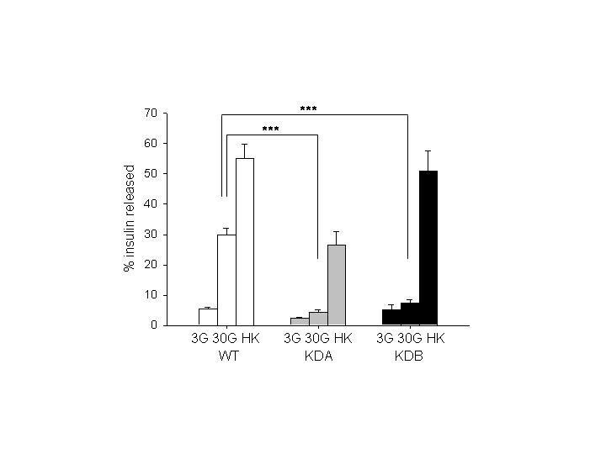Fig.1A
1
2
3
4
5
6
7
8
9
10
11
12
13
14
15
16
17
18
19
20
21
22
23
24
25
26
27
28
29
30
31
32
33
34
35
36
37
38

Fig1B.
1
2
3
4
5
6
7
8
9
10
11
12
13
14
15
16
17
18
19
20
21
22
23
24
25

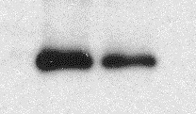C KO

WFS1

BA
% insulin released
Human Molecular Genetics

2.5

2

1.5

1

0.5

0

***
Page 40 of 48
26 3G 17G HK 3G 17G HK

27 C KO
28
29
30
31
32
33
34
35
36
37
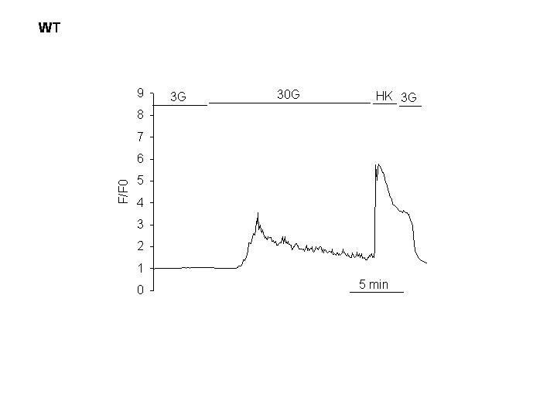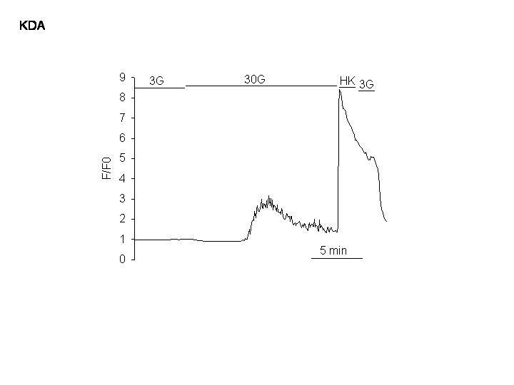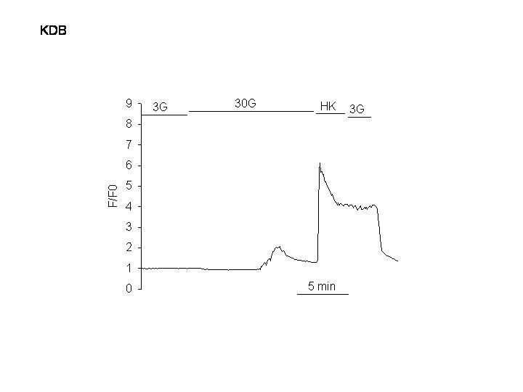

For
Peer

Review
Page 41 of 48 | Human Molecular Genetics
2A | 2B | 2C
1
2
3
4
5
6
7
8
9
10
11
12
13
14
15
16
17
18

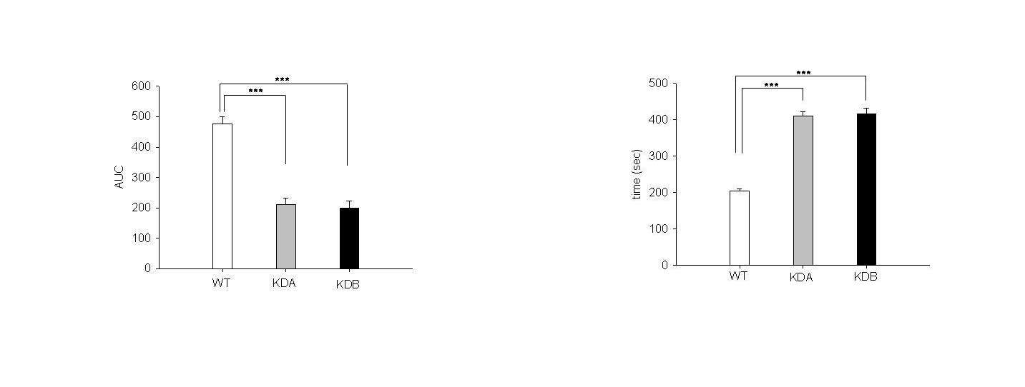
19  20 | 2D | 2E
21
22
23
24
25
26
27
28
29
30
31
32
33
34
35
36
37

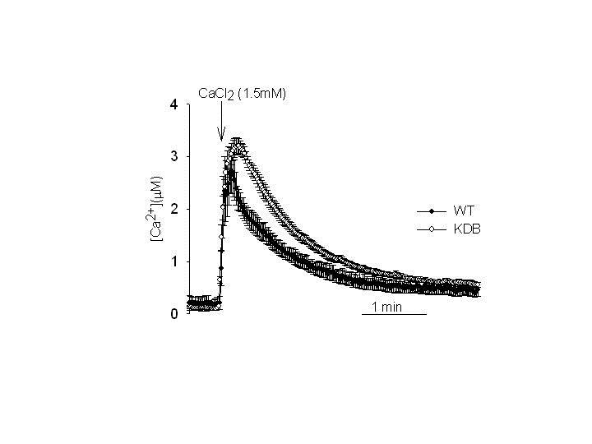Human Molecular Genetics
Page 42 of 48

For
Peer

Review

1
2
3 Fig.3
4
5
6
7
8
9
10
11
12
13
14
15
16
17
18
19
20
21
22
23
24
25
26
27
28
29
30
31
32
33
34
35
36
37
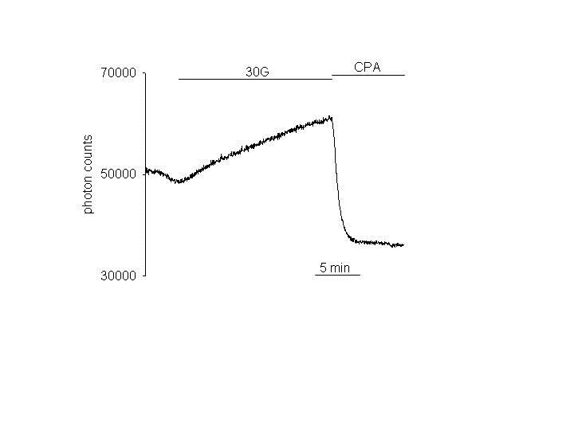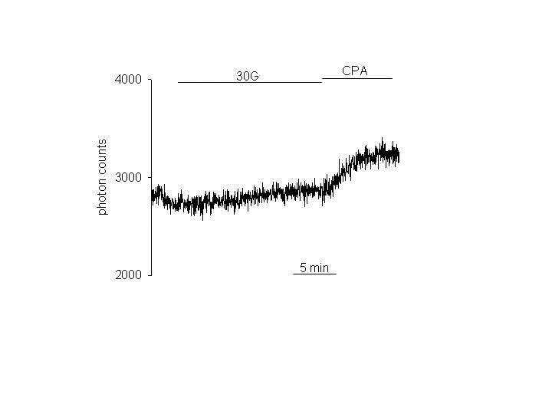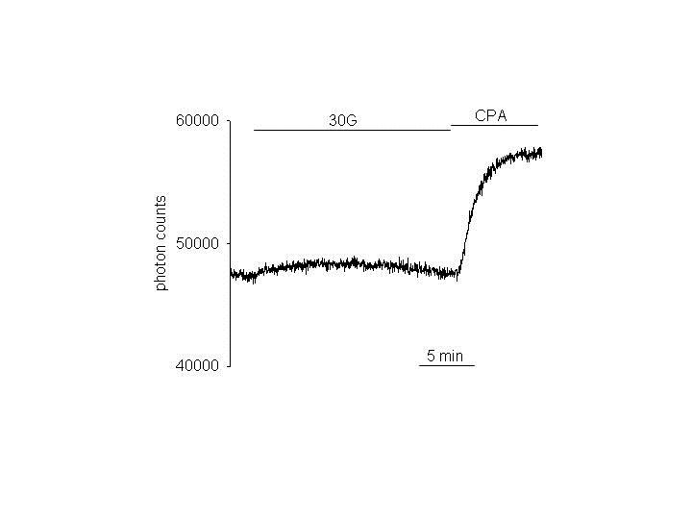Page 43 of 48 Human Molecular Genetics

For
Peer

Review
Fig.4A Fig.4B Fig.4C
1 wt KDA KDB
2
3
4
5
6
7
8
9
10
11
12
13
14
15
16 Fig.4D
17
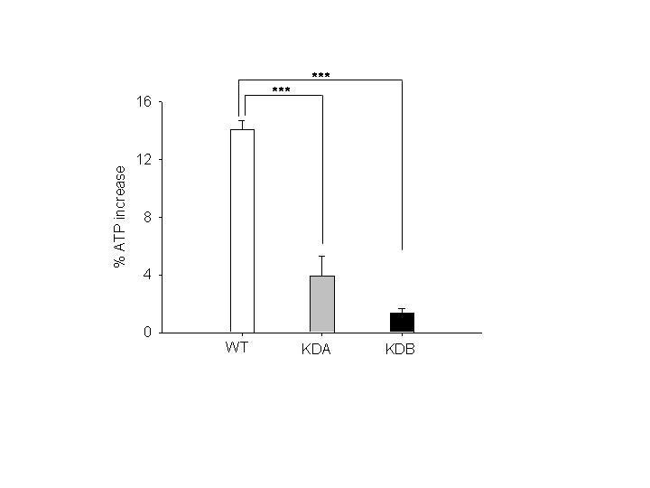18
19
20
21
22
23
24
25
26
27
28
29
30
31
32
33
34
35
36
37
38
39
40

FIG 5 AB
Human Molecular Genetics
Page 44 of 48

1
2
3
4
5
6 A
7
8
9
10
11
12
13
14
15
16
17
18
19
20
21
22 B
23

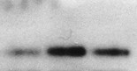1 2 3

SERCA PDI

400 *
SERCA rela7ve expression (%)
350

300

250

200

150

100

50

0

C KDB KDA

200
SERCA rela7ve expression (%)
24 C KO

25
26
27
28
29
30
31
32
33
34
35
36

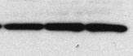SERCA BA
180
160
140
120
100
80
60
40
20
0
**

C KO
Page 45 of 48 Human Molecular Genetics

Fig 5 CD.
1
2
3
4
5 C
6
7
8
9
10
11
12
13
14
15
16
17
18

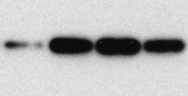 1 2 3 4

SERCA BA
SERCA expression (%)

400

350

300

250

200
SERCA2 expression (%)

150

100

50

0

*

**

**

19

For
Peer

Review
20
21
22
23 D
24
25
26
27
28
29
30
31
32
33
34
35
36

1 2 3 4

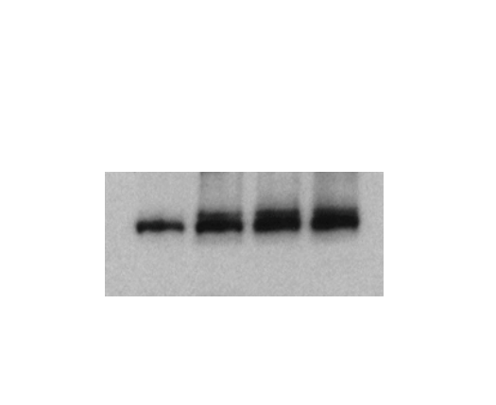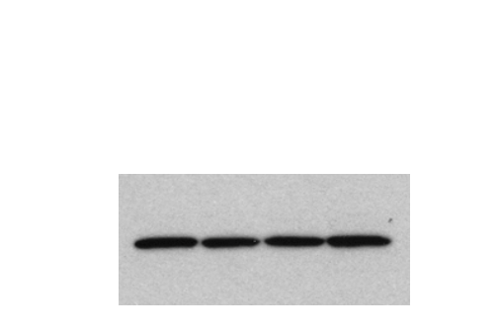SERCA2 BA

450
400
350
300
250
200
150
100
50
0
C KD1 KD2 KD3

* *

*

C KD1 KD2 KD3
Fig 6.

1 A
2
3

Input

IP: FLAG
Human Molecular Genetics

B
I

Input

IP:Myc
Page 46 of 48
4 Myc-W1
5 E-Myc
6
7 FL-SERC
8
9 E-FL
+ + - - + + - - +
- - + + - - + + -

+ - + - + - + - +
- + - + - + - + -
Myc-W1

E-Myc
FL-SERC

E-FL
+ + - - + + - -
- - + + - - + +

+ - + - + - + -
- + - + - + - +
10
11
12
13
14
15
16
17
18
19
20
21
22
23 C
24
25
1 2 3 4

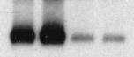

Input

Myc

W1

FLAG BA
1 2 3 4 5

IP

100kDa

100kDa

110kDa

D
Input
1 2 3 4

I

FLAG Myc BA

IP
1 2 3 4

110 kDa

100kDa
26

27
28 SERCA2
29
30
31
32
33
1 2 3 4 5 6

110 kDa
D U
SERCA2
WFS1

BA
1 2 3 4 5

0.38 1.0
1.0 1.0

SERCA2 110 kDa

WFS1 100 kDa
Page 47 of 48 Human Molecular Genetics

1

2 Fig 7.
3
4
5
6
7
8
9
10
11
12
13
14
15
16
17
18
19 | 1 | 2 | 3 | 1 | 2 | 3
20
21
22
23
24
25
26
27
28
29
30

C KD2

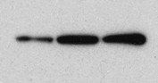MG132 MG132

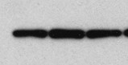SERCA BA

350

300

250
SERCA expression (%)

200

150

100

50

0

* *

DMSO MG132_5 MG132_10

C KD2
Fig 8
Healthy person

Human Molecular Genetics
Wolfram syndrome

Page 48 of 48

SERCA

14
15
16
17 WFS1
18
19
20
21
22
23

SERCA
degraded

ER stress
1 | SERCA levels controlled by WFS1 | WFS1
2
3
4
5
6 | WFS1 SERCA
7 |  | Mutated WFS1
8
9 |  | ER stress
10
11
12 | Physiological levels
13 | of SERCA turnover | SERCA not

WFS1

SERCA
compensatory Ca pumping to ER
Complex not formed degraded

SERCA
upregulation
compensatory Ca pumping to ER
24 Physiological

25 SERCA levels
26
27
28
29
30
31
32
33
34
35
36
37
38
39
40
41
42
43
44
45
46
Complex not formed
SERCA not degraded

SERCA
upregulation

In time in WFS1 depleted cells unresolvable ER stress will develop due to impairment of multiple WFS1 function.

Cell death

