Published in Global Journal of Agricultural Research (2015), 3(3): 11-24
FARMERS’ PERCEPTION OF SOIL: IMPLICATIONS FOR SOIL CONSERVATION AND SUSTAINABLE AGRICULTURE IN THE UK

Franklin I. Duruiheoma (Corresponding author)
Department of Biological Sciences, University of Chester
E-mail: f.duruiheoma@chester.ac.uk

Cynthia V. Burek
Department of Biological Sciences, University of Chester

Graham Bonwick
The Institute of Food Science and Innovation, University of Chester

Roy Alexander
Department of Geography and International Development, University of Chester
Abstract
We identify UK farmers’ perception of soil, awareness of soil in terms of how they describe it, their awareness of its benefits other for than crop production, their familiarity with soil conservation, and their opinions on soil protection and the value of organic fertilizers. Data were collected with the aid of social media using both Twitter and electronic mail to distribute a survey link to farmers. UK yellow pages, Natural England directory and Twitter were used to search for farms. Data were analysed using SPSS version 22.0 statistical software and Wordle. Chi square was used to test for relationships between variables at 95% confidence level (p<0.05), while Phi and Cramer’s V were used to measure strength of association for significant relationships. Results showed that farmers’ describe soils in abstract, scientific, physical attribute and functional terms. Awareness of soil benefits other than crop production was significantly related to age, and farm ownership. Educational level was significantly related to familiarity with soil conservation, and opinion on whether soil should be protected like other natural resources. The implications of these results for soil conservation and sustainable agriculture are discussed and used as, the basis for policy recommendations.
Keywords: Anaerobic digestion (AD), Ethnopedology, Soil conservation, Sustainable agriculture, Perception

- INTRODUCTION
Soils are an important component of the environment. They provide habitat for biodiversity, platform for buildings, recreation, organic materials, food and feed; they support agricultural production, water storage and nutrient cycling; they regulate water quality and supply, climate and, atmospheric gases; and they make up part of our natural heritage (Haygarth and Ritz 2009). Some anthropogenic and natural processes reduce the capacity of soils to deliver these functions. These include: soil erosion, population growth, intensified agriculture, deforestation, and inorganic fertilizer use. These processes directly and indirectly cause changes in the biological, chemical and physical properties of soils, leading to a global decline in soil quality (Tesfahunegn et al. 2011). While soil erosion is widely recognised as a major factor in soil degradation and decline in soil quality (Hannam and Boer 2004; Morgan 2005), population growth and resulting food security concerns have promoted the need to conserve soils at the international, regional and national scale (Hannam and Boer 2004; Khanif 2010; Schneider et al. 2010; Nkegbe 2013; Sudha 2015). Population growth decreases available agricultural land through development in the form of soil sealing. It also increases pressure on available agricultural land for food production, thereby leading to intensified agricultural production. Intensification of agricultural production encourages the use of inorganic fertilizers to maintain soil fertility, however, their long term impact on the environment mainly water contamination which affects human health make their use less ideal for soils (Schiermeier 2013).
Soil conservation efforts have taken the form of land policies to encourage better farming practice such as zero tillage (Schneider et al. 2010), less inorganic fertilizer use (Schiermeier 2013; Karltun et al. 2013) and those non-agricultural practices that expose soils to degradation such as deforestation. Zero-tillage involves crop production on undisturbed soils using specialised machinery and weed control with herbicides. In this way the soil structure remains undisturbed and susceptibility to erosion is reduced. Legislation and policies to enforce soil conservation within the UK, such as code for good agricultural practice for soil, are weak and are hardly enforcing on farmers (Ingram and Morris 2007). At the European level, the Thematic Strategy for Soil Protection was adopted in 2006 to encourage soil conservation among member states, but a proposed soil directive for the EU was withdrawn in May 2014. However, the Seventh Environment Action Programme which came into action in January 2014, acknowledges the severity of soil degradation and set a target of sustainable soil management by 2020 (EC 2015). Central to this programme is the minimisation of soil erosion and increase in organic matter content of soils. At the international level, IUCN Resolution of 2000 on the Sustainable Use of Soils is the main legislative framework that has guided the development of soil conservation initiatives (Hannam and Boer 2004). Even though legislation is considered an important tool for soil conservation (Hannam and Boer 2004, Towers et al. 2005), it is inadequate to control the rapid rate of soil degradation globally.
The recognition of the inadequacies in policy and legislation for soil conservation has led to a gradual shift in conservation efforts towards the assessment of knowledge of farmers about soils (Ingram et al. 2010; Karltun et al. 2013; Schiermeier 2013; Rushemuka et al. 2014), and their soil management practices (Nkegbe 2013; Kings 2014; Tesfaye et al. 2014; Sudha 2015). This shift in soil conservation efforts recognises farmers as primary players in the conservation of soils. Assessing farmers’ knowledge of soil is necessary for the development of more effective policies and soil management initiatives (Tesfahunegn et al. 2011). This approach is similar to ethnopedology, which is the study of local knowledge of soil (WinklerPrins and Sandor 2002), and the main difference is that some studies have been more focused on farmers’ soil management practices and therefore lack the full integration of topics covered in ethnopedology. This research however, not only looks at farmers’ knowledge of soil and its benefits, but also their knowledge of soil conservation, the need to protect soils, and organic fertilizer use. Building on the principles of ethnopedology, this research aims to relate farmers’ description of soils to scientific information, and furthermore to relate farmers’ knowledge to their individual demographic characteristics. The study also builds on earlier reports of Duruiheoma et al. (2014) on the need to raise awareness on the benefits of AD in the UK to encourage its uptake among farmers, but for this to be effective its critical to understand farmers’ perceptions of soils so that messages can be framed appropriately. In addition, recommendations on soil management policies, initiatives and conservation efforts are made based on the relationships observed between farmers’ demographic characteristics and their knowledge, and opinions.
- METHODOLOGY
  - Study participants
A total of 283 UK farmers participated in the survey used for this research. The distribution of respondents across England, Scotland, North Ireland and Wales is presented in Figure 1. The points on the map represent the approximate location of the counties where participating farms are located. These points do not however, include the county location of all 283 farmers that participated in the survey as already reported in Duruiheoma et al. (2015a).
  - Recruitment process and measurements
The process of farmers’ recruitment has been reported in detail in Duruiheoma et al. (2015a). In brief, it involved the use of the farm directory of Natural England, the Yellow Pages business directory for the UK, e-mail communication and Twitter. The directories and Twitter were used to search for farms, while both the e-mail account and Twitter were used to distribute the survey link to farmers. Twitter proved to be a very useful tool for the survey process. Open and closed questions were included in the survey questionnaire. Table 1 shows the dependent variables used. The independent variables and their units have been presented in Duruiheoma et al. (2015a); they include: gender, age, farm type, education, farm ownership, farm size (in hectares) and farm topography.

Table 1. Dependent variables used in survey questionnaire
Variables | Units
What 4 key words would you use to describe soils?  Are you aware of the benefits of soils other than crop production?  How familiar are you with soil conservation?  Should soils be protected like other natural resources?  Do you think organic fertilizers are good for soils? | Open-ended  1 ‘Yes’, 2 ‘No’  1 ‘Very familiar’, 2 ‘Familiar’, 3 ‘Heard of but could not explain’, 4 ‘Never heard of’  1 ‘Yes’, 2 ‘No’  1 ‘Yes’, 2 ‘No’

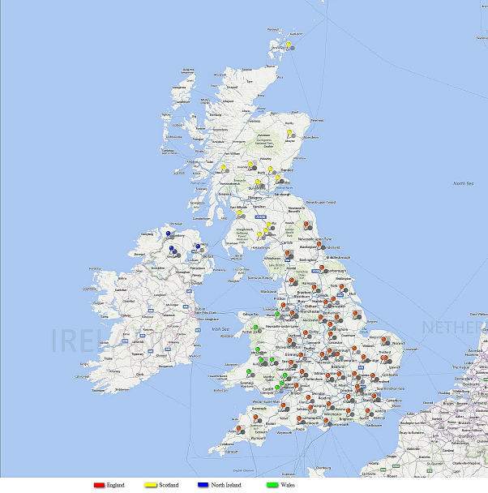
Figure 1. Distribution of participating farms across the UK
© Duruiheoma et al. (2015a)

  - Data analysis
Data were analysed using SPSS statistical software version 22.0. Analysis involved testing for relationships between dependent and independent variables (excluding topography), and also within the dependent variables at 95% confidence level (p<0.05). Phi and Cramer’s V values were used to measure the significant relationships observed, and basic Chi square assumptions using SPSS were observed (Field 2009; Pallant 2013). For the open ended question on soil description, Wordle was used to count words and create ‘word clouds’ at wordle.net. The ‘word clouds’ are presented as figures in the result section of this report.
Descriptive statistics are used to present the response distribution for closed questions.

- RESULTS
  - Response distribution of variables
Table 2 shows the response distribution of independent variables. Male farmers were more frequent respondents than female. Percentage responses were distributed fairly evenly across age groups with the exception of ‘61-70’ and ‘above 70’.
Table 2. Independent variable distribution
© Duruiheoma et al. (2015a)

Variables | Options provided | Response percentage
Gender | Female  Male | 30.4%  69.6%
Age | Less than 30  30-40  41-50  51-60  61-70  Above 70 | 21.9%  22.9%  24.4%  20.8%  9.3%  0.7%
Farm type | Arable  Livestock (dairy and meat)  Mixed (arable and livestock)  Horticulture  Other | 16.0%  42.3%  33.8%  4.6%  13.5%
Level of education | GCSE or equivalent  A levels or Equivalent  Diploma  Degree  Postgraduate degree  Other | 8.4%  9.1%  23.6%  42.9%  12.4%  3.6%
Farm ownership | Owner  Manager  Tenant  Other | 55.4%  18.2%  11.1%  15.4%
Farm size | Less than 30ha  30-60ha  61-90ha  Above 90ha | 15.5%  14.4%  10.8%  59.4%
Farm topography | Upland  Lowland | 18.5%  81.5%
The least common farm type in the categories provided was horticultural. Responses also show that more than 70% of farmers surveyed had at least a Diploma level of qualification. Tenancy was the least common type of farm ownership identified at 11.1%. The table also shows that more than 70% of farms surveyed were larger than 60 hectares (ha). Most farms surveyed were on lowland, located mainly in the Southern part of the UK (Figure 1).
Table 3. Dependent variable distribution
Variables | Options provided | Response percentage
Are you aware of the benefits of soils other than crop production? | Yes  No | 83.8%  16.2%
How familiar are you with soil conservation? | Very familiar  Familiar  Heard of but could not explain  Never heard of | 25.3%  56.8%  15.3%  2.6%
Should soils be protected like other natural resources? | Yes  No | 92.7%  7.3%
Do you think organic fertilizers are good for soils? | Yes  No | 91.4%  8.6%
Responses revealed that most of the study participants claim to know the benefits of soils other than crop production. Although participants were not asked to mention other benefits of soils they are aware of, their responses suggest strongly that most of the farmers surveyed may have some information on the various functions of soil discussed in the Introduction. In terms of soil conservation, more than 80% of participants were at least familiar with the concept. This percentage also represents those participants that believe they can explain what soil conservation means. Similarly, a large majority of participants agree that soils should be protected like other natural resources, which is in line with the level of awareness of the other functions of soils and soil conservation. The use of organic fertilizers also gained wide support from participants.
  - Soil descriptions
A total of 213 (75.3% of all participants) farmers responded to the question on four key words to describe soils, although this percentage declined slightly and progressively from the first to fourth key word. 208 participants provided first and second key words, 204 first to third key words, and 194 provided the complete four key words. The responses show a diversity of words that can be used to describe soils. Figure 2 shows the common first key words used to describe soil. The words used here are more abstract with words like ‘essential’ being the most popular first key word. Other popular key words, like ‘alive’, ‘vital’, ‘heavy’ and ‘fertile’ also suggest a broad view of soils shared by the farmers. The second (Figure 3) and third (Figure 4) key words used indicated that participants have some ‘scientific’ knowledge of soils with ‘clay’, ‘humus’, ‘structure’, ‘nutrients’, ‘organic’ and ‘pH’ more common. A closer look at Figure 3, also shows that most of the common second key words used are associated with soil physical characteristics. In addition to showing some ‘scientific’ knowledge about soil, the third key words covered both soil functions and abstract descriptions.
The fourth key words (Figure 5) consisted mainly of a mixture of abstract and scientific terms with words like ‘loam’, ‘productive’, ‘structure’, ‘organic matter’, ‘essential’ and ‘complex’ being most popular. Overall (Figure 6), the words used to describe soil fall into four categories, namely: abstract, scientific, physical soil attributes, and soil function.
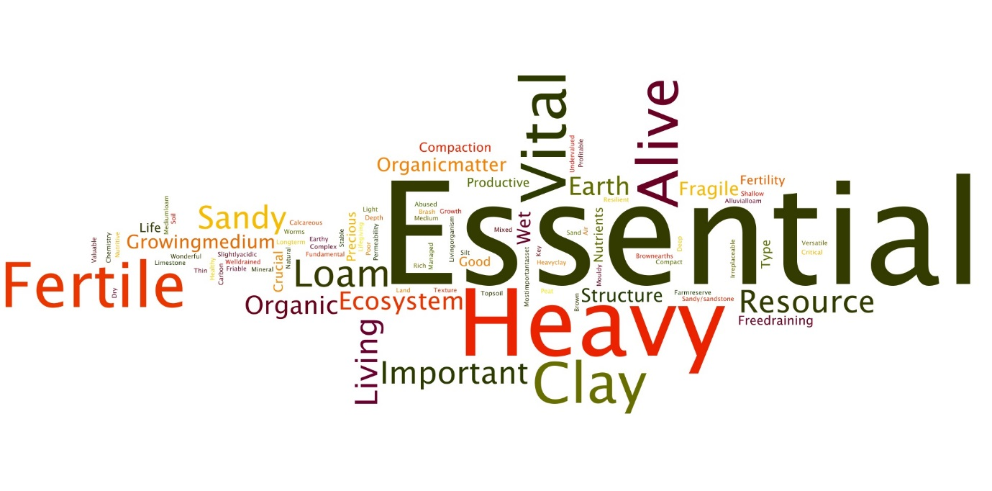
Figure 2. First key words used to describe soils

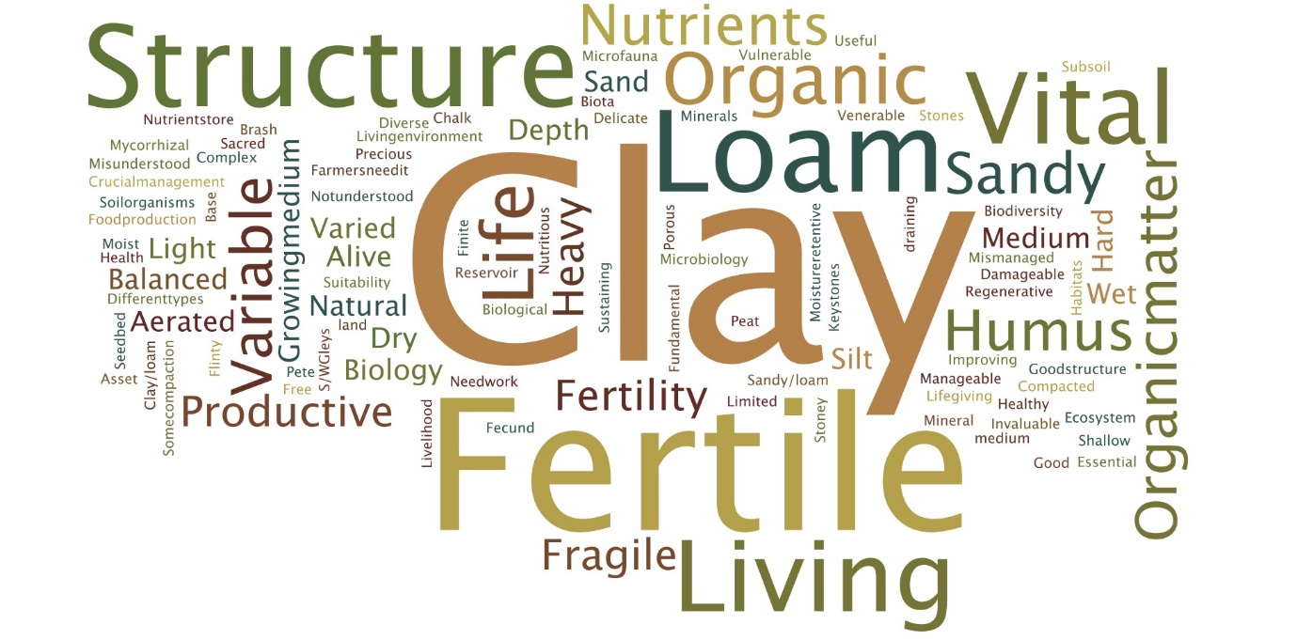
Figure 3. Second key words used to describe soils
  - Interactions between variables
Table 4 shows the results of the test between dependent and independent variables. Gender, farm type and size had no significant relationship with any of the dependent variables. The closest to a significant relationship with gender (p=0.073) was observed on opinion on whether soils should be protected like other natural resources. The results, though not significant, showed that a greater percentage of female participants answered ‘yes’ to the question. A similar relationship was observed with farm size, with the highest percentage of ‘yes’ coming from participants with farm size between ‘61-90ha’, again this is not significant (p=0.095).
Age has a significant relationship with awareness of the benefits of soils other than crop production (p=0.003), and this association has a small to medium strength (Cramer’s V=0.272). The results showed that the percentage of farmers aware of the benefits of soils other than crop production increased progressively with age. Age also showed a near significant relationship with opinion on whether organic fertilizers are good for soil (p=0.068). This result might have been significant if there were more participants in the older age groups.
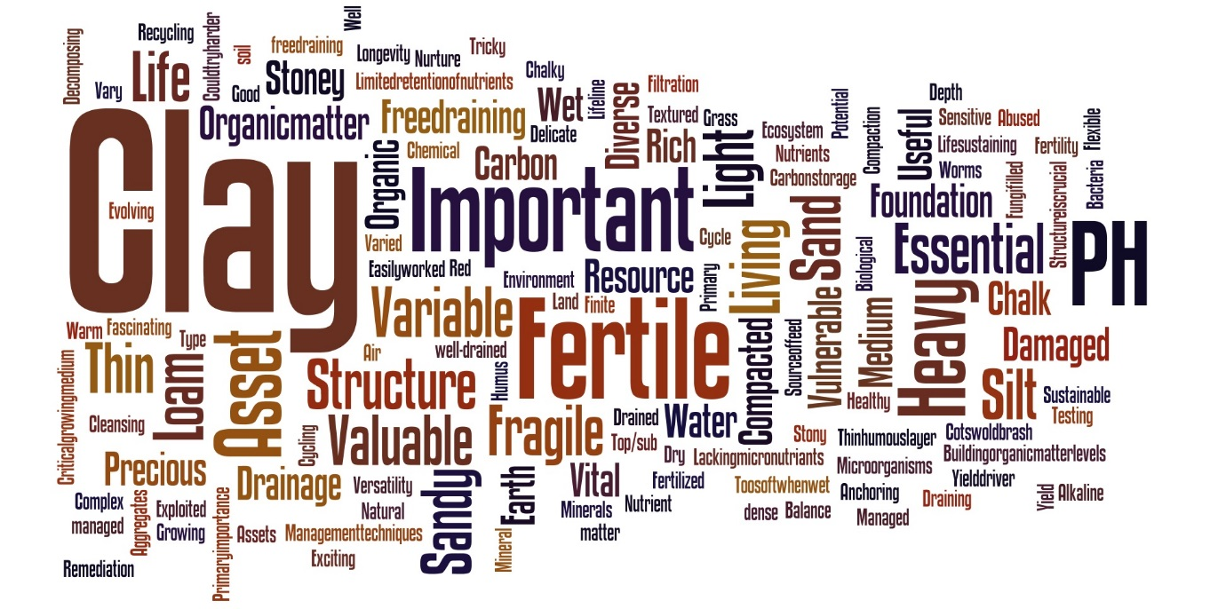
Figure 4. Third key words used to describe soils

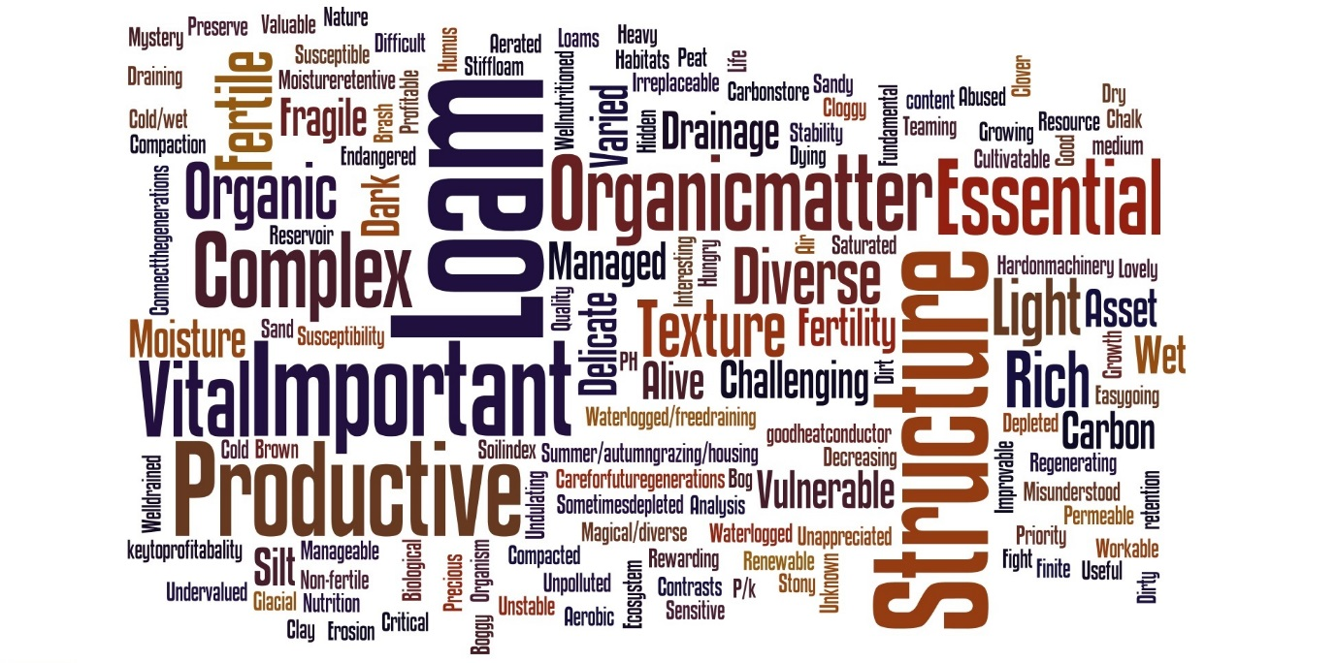
Figure 5. Fourth key words used to describe soils

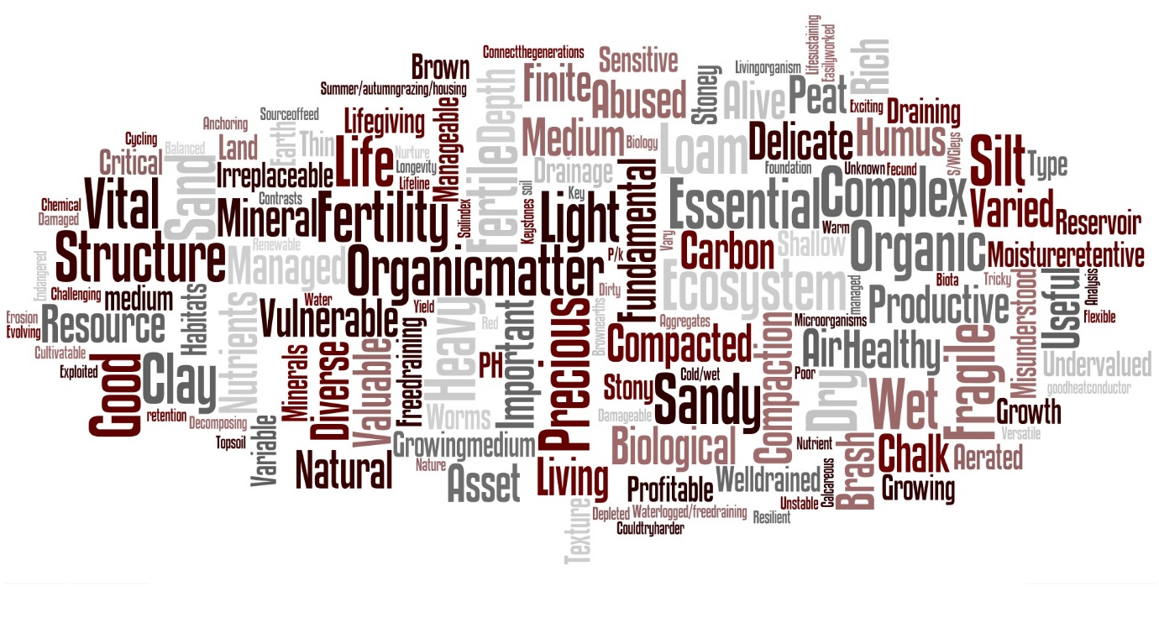
Figure 6. Overall key words used to describe soils
Level of education showed a significant association with both familiarity with soil conservation and opinion on whether soils should be protected like other natural resources (Table 4) and the strength of association in both cases was medium to large (Cramer’s V=0.19 and 0.252 respectively). Percentage familiarity with soil conservation increased with educational level. However, farmers with ‘A level or equivalent’ were least familiar with soil conservation followed by those with ‘diploma’. A similar trend was observed with opinion on whether soils should be protected like other natural resources. The main difference here was that, famers with ‘GCSE or equivalent’ had the highest ‘yes’ percentage.
Farm ownership was significantly related to awareness of the benefits of soil other than crop production, with a small to medium strength (Cramer’s V=0.252). Results showed that farm owners were more aware of these benefits, followed by tenant farmers.
Table 4. Observed p values for test between dependent and independent variables
Independent  Dependent | Gender | Age | Farm type | Level of education | Farm ownership | Farm size
Awareness of the benefits of soils other than crop production | .523 | .003* | .330 | .216 | .002* | .857
Familiarity with soil conservation | .408 | .123 | .104 | .019* | .794 | .540
Opinion on whether soils should be protected like other natural resources | .073 | .865 | .431 | .016* | .465 | .095
Opinion on whether organic fertilizers are good for soils | .996 | .068 | .858 | .482 | .914 | .609
*significant relationship
Significant relationships were observed both between awareness of the benefits of soil other than crop production and familiarity with soil conservation, and between opinion on whether soils should be protected like other natural resources and opinion on whether organic fertilizers are good for soils (p=0.0001 and 0.045 respectively). Figure 7 shows that the more familiar farmers are with soil conservation the more likely they are to be aware of the benefits of soils other than crop production and vice versa. The strength of this association is large (Cramer’s V=0.508). For opinions on whether soils should be protected like other natural resources against whether organic fertilizers are good, the results showed that participants who agreed with one were more likely to agree with the other, and the association was small to medium, with (Phi value=0.154).
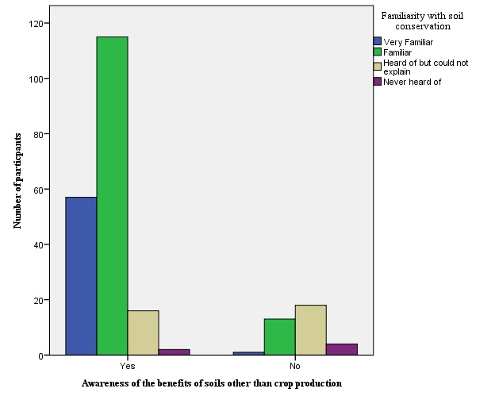
Figure 7. Distribution of responses between awareness of the benefits of soils other than crop production and familiarity with soil conservation

All significant relationships observed in this analysis suggest that the type of associations detected between variables did not happen as a result of sampling or by chance, and similar relationships can be expected from a wider sample of the UK farming population with a 95% confidence level.
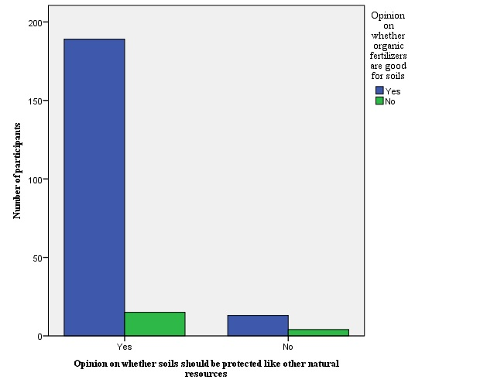
Figure 8. Distributions of responses between opinions on whether soils should be protected like other natural resources and whether organic fertilizers are good for soils
- DISCUSSION
The description of soils given by farmers in this study suggest that farmers have some knowledge about soils. The study also shows that not only do farmers have a different knowledge of soils from scientists (Ingram et al. 2010), but that there is a difference among farmers themselves looking at the number of words used to describe soils. The findings of the study are not limited to differences in the perception of soils among farmers, but also include certain similarities in their perception of soils. This is particularly relevant considering the diversity in the farmers’ age groups, educational level, farm type and other independent variables that had significant associations with the dependent variables.
The words used to describe soils, which have been categorised into abstract, scientific, physical, and soil function descriptions were closely linked to responses on the dependent variables. For instance, the description of soils as ‘essential’ very much suggest that farmers may actually know the various functions of soil other than crop production. Other descriptions of soils, such as ‘organic matter’, also suggest why most famers agreed that organic fertilizers are good for soils. Similarly, descriptions of soil as ‘important’, ‘vital’, ‘living’ and ‘essential’ make responses on opinions on whether soils should be protected like other natural resources less surprising. There is no doubt farmers possess good knowledge of their local soils, as various studies have suggested (Ingram et al. 2010; Schiermeier 2013; Rushemuka et al. 2014; Tesfaye 2014), the main question is how this knowledge can be translated into effective soil conservation practices for sustainable agriculture. Although results showed a high level of awareness of the benefits of soils other than crop production, its association with age and farm ownership suggest the need to effectively engage farmers in knowledge exchange networks for the overall benefit of soil conservation. With higher awareness of the benefits of soil in older farmers and ‘farm owners’, a possible knowledge transfer network between farmers can involve the older farmer and ‘farm owners’ sharing their knowledge about soils. Farmers within these categories can also be positioned to serve the interest of farmers in the development of soil conservation policies in the UK. Other authors have reported, the need for farmers’ participation in soil conservation (Sudha 2015) and sustainable agriculture (Harris et al. 2008) policies, particularly involving those farmers with more awareness of the benefits of soil in such activities. However, participation should go beyond stakeholder engagement as such farmers could make significant contributions to policy development.
High levels of familiarity with soil conservation were also reported in the results and, while it remains unclear whether or not farmers actually know what soil conservation entails, the association observed between it and educational level offers opportunity for soil conservation and sustainable agriculture in the UK. Since farmers were not asked to define soil conservation, it is not certain how familiar they are, however previous studies (Ingram 2008; Ingram et al. 2010; Kings 2014) and results from this study, especially the medium to large association with educational level, suggest that UK farmers might be indeed be familiar with soil conservation. With the expectation that the more educated farmers will be more familiar with soil conservation, highly educated farmers can play a leadership role in soil conservation networks between farmers. Opinion on whether soils should be protected like other natural resources also shared a medium to large association with education and therefore supports the role for highly educated UK farmers in soil conservation.
Although opinion on the use of organic fertilizers on soils did not share a significant association with any independent variable, it had a significant association with opinions on whether soils should be protected like other natural resources and there was an overall high support for organic fertilizer use on soils. Earlier Duruiheoma et al. (2015b) identified the importance of anaerobic digestion (AD) technology in promoting soil conservation and sustainable agriculture. Rich organic fertilizer called the digestate is one of the benefits of AD reported, and the support for organic fertilizer on soils here shows that informing UK farmers of the benefits of AD can promote its development, thereby supporting sustainable agricultural production.

- CONCLUSION
Building on the principles of ethnopedology, this study has shown the perception UK farmers have of soils and how this can influence soil conservation and sustainable agriculture. The results show that UK farmers have scientific knowledge of soils, awareness of the various benefits of soils and are quite aware of soil conservation. Age, farm ownership and level of education shared significant association with some dependent variables, and these associations can be useful in efforts to promote soil conservation and sustainable agriculture in the UK. The association between opinion on the need to protect soils like other resources and support for organic matter use on soils as well as their response distribution supports the promotion of AD technology in the UK. Also, the use of Twitter for data collection in this study stresses the importance of social media in agricultural research.
This paper represents a useful tool in the development of policies and programs for soil conservation and sustainable agriculture, agricultural research in these areas within the UK, and developing message to encourage the uptake of AD among UK farmers. The methodology can effectively be applied elsewhere, considering the overwhelming presence of social media globally.

- RECOMMENDATIONS
Based on the findings of this research, the following recommendations are made:
- A participatory approach that will involve farmers should be considered in the development of agricultural programs on soil conservation and sustainable agriculture in the UK and elsewhere.
- Farmer knowledge transfer networks focused on ‘soil matters’ can be constituted to foster soil conservation in the UK targeting older farmers and more educated farmers as key figures within such networks.
- Social media offers opportunities for agricultural research and should be considered a viable methodological option in future. There is however need to recognise its limitations as reported in Duruiheoma et al. (2015a).
REFERENCES
Duruiheoma, F. I., Burek, C., Bonwick, G. & Alexander, R. (2014) Raising Awareness of Anaerobic Digestion in the UK- Views of Key Stakeholders. Journal of Environment and Ecology, Vol. 5 (2): 258-275.
Duruiheoma, F. I., Burek, C., Bonwick, G., & Alexander, R. (2015a) Farmers’ Interest in Agricultural Technology and Organic Farming: Implications for AD Adoption and Sustainable Agriculture in the UK, Environmental Management and Sustainable Development, 4(1), 242-263.
Duruiheoma, F. I., Burek, C., Bonwick, G., & Alexander, R. (2015b) The Role of Anaerobic Digestion in Achieving Soil conservation and Sustainable Agricultural Development in the UK, Journal of Environment and Ecology, Vol. 6 (2) (In press).
EC: European Commission (2015) Soil. Brussels: EC, available at: http://ec.europa.eu/environment/soil/index_en.htm
Field, A. P. (2009) Discovering statistics using SPSS: And sex and drugs and rock 'n' roll, 3rd edition. London: SAGE.
Hannam, I. and Boer, B. (2004) Drafting Legislation for Sustainable Soils: A Guide. Gland, Switzerland and Cambridge, UK: IUCN. x + 100 pp.
Harris, F., Lyon, F. andClarke, S. (2008). Doing interdisciplinary: motivation and collaboration in research for sustainable agriculture in the UK, Area, Vol. 41(4), 374-384.
Haygarth, P. M. and Ritz, K. (2009) The future of soils and land use in the UK: Soil systems for the provision of land-based ecosystem services, Land Use Policy, Vol. 26S: S187-S197.
Ingram, J. and Morris, C. (2007). The knowledge challenge within the transition towards sustainable soil management: An analysis of agricultural advisors in England, Land Use Policy, 24, 100-117.
Ingram, J. (2008) Are farmers in England equipped to meet the knowledge challenge of sustainable soil management? An analysis of farmer and advisor views, Journal of Environmental Management, 86, 214-228.
Ingram, J., Fry, P. and Mathieu, A. (2010) Revealing different understandings of soil held by scientists and farmers in the context of soil protection and management, Land Use Policy, 27, 51-60.
Karltun, E., Lemenih, M. and Tolera, M. (2013) Comparing Farmers’ Perception of Soil Fertility Change with Soil Properties and Crop performance in Beseku, Ethiopia, Land Degradation & Development, 24, 228-235.
Khanif, Y. M. (2010) Improvement of soil carrying capacity for better living, J. ISSAAS, Vol. 16(1), 1-7.
Kings, D. (2014) Farmers’ Understanding of Weeds and Herbicide Usage as Environmental Influences on Agricultural Sustainability, Journal of Environmental Protection, 5, 923-935.
Morgan, R. P. C. (2005) Soil Erosion and Conservation, 3rd edition, Oxford: Blackwell publishing
Nkegbe, P. K. (2013) Soil Conservation and Smallholder Farmer Productivity: An Analytical Approach, Journal of Management and Sustainability, 3(2), 92-99.
Pallant, J. (2013). SPSS survival manual: A step by step guide to data analysis using SPSS, 5th edition. Maidenhead: Open University Press/McGraw-Hill Education.
Rushemuka, N. P., Bizoza, R. A., Mowo, J. G. and Bock, L. (2014) Farmers’ soil knowledge for effective participatory integrated watershed management in Rwanda: Toward soil-specific fertility management and farmers judgemental fertilizer use, Agriculture, Ecosystems and Environment, 183, 145-159.
Schiermeier, Q. (2013) Farmers dig into soil quality, Nature, vol. 502, 607.
Schneider, F, Ledermann, T., Fry, P. and Rist, S. (2010) Soil conservation in Swiss agriculture-Approaching abstract and symbolic meanings in farmers’ life-worlds, Land Use Policy, 27, 332-339.
Sudha, S. C. R. (2015) Investment, adoption, attitude and extent of participation of farmers in soil conservation projects in Western Ghats of India, International Journal of Social Economics, 42(3), 251-275.
Tesfahunegn, G. B., Tamene, L. and Vlek, P. L. G. (2011) Evaluation of soil quality identified by local farmers in Mai-Negus catchment, northern Ethiopia, Geoderma, 162, 209-218.
Tesfaye, A., Negatu, W., Brouwer, R. and Van Der Zaad, P. (2014) Understanding Soil Conservation Decision of Farmers in the Gedeb Watershed, Ethiopia, Land Degradation & Development, 25, 71-79.
Towers, W., Malcolm, A. and Bruneau, P.M.C (2005). Assessing the nature conservation value of soil and its relation with designated features, Scottish Natural Heritage Commissioned Report No. 111 (ROAME No. F03AC104).
WinklerPrins, A. M. G. A. and Sandor, J. A. (2002) Local soil knowledge: insights, applications and challenges, Geoderma, 111, 165-170.

